**INTERNSHIP REPORT**

**at**

**DELMAN SHIPPING LLC**

**Submitted to**

**MAHATMA GANDHI UNIVERSITY, KOTTAYAM**

**In partial fulfillment of the requirements for the award of the degree of**

**MASTER OF BUSINESS ADMINISTRATION**

**2024-2026**

**Submitted by**

**HARISANKAR ASOKAN**

**Reg. No: 240402227**



**BHARATA MATA INSTITUTE OF MANAGEMENT**

**BHARATA MATA COLLEGE(AUTONOMOUS)**

**THRIKKAKARA -682021**

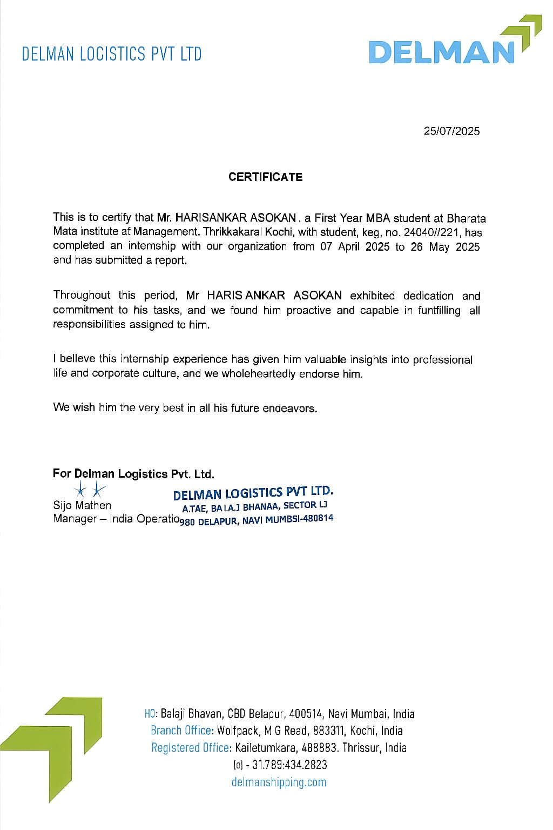

**BHARATA MATA INSTITUTE OF MANAGEMENT**

**BHARATA MATA COLLEGE(AUTONOMOUS)**

THRIKKAKARA P.O., COCHIN – 682 021, KERALA

Tel: 0484-2423626, 2425121 Fax: 0484-2427796.

### CERTIFICATE

This is to certify that this report is a bonafide record of Internship undergone by Mr. HARISANKAR ASOKAN at DELMAN SHIPPING LLC in partial fulfillment of the requirements of the **Master of Business Administration (MBA)** programme of Mahatma Gandhi University under my guidance. It is also certified that this report has not been submitted to any other Institute/University for the award of any Degree/ Diploma.

However, this certificate is not issued to endorse the views and opinions expressed in this report.

Dr. Megha Mary Michael

Academic Guide

Date: 23/06/2025

Place: Thrikkakara

Forwarded External Examiner

Prof. (Dr.) B. HAREENDRAN

Academic Director

**DECLARATION**

I Harisankar Asokan hereby declare that this Report is a bonafide record of Summer Internship undergone by me at Delman Shipping LLC during 7th April 2025 to 24th May 2025, in partial fulfillment of the requirements of the **Master of Business Administration (MBA)** programme of Mahatma Gandhi University. It is also declared that this report has not been submitted to any other Institute/University for the award of any Degree/ Diploma.

**Harisankar Asokan**

Thrikkakkara

**ACKNOWLEDGEMENT**

“Having an attitude of gratitude every day, makes us aware of the blessings that come our way” goes the sayings: expressing gratitude is always a pleasant duty I am thankful to the almighty for all the blessings given to me.

I am grateful to thank **Rev.Fr. (Dr.) Abraham Oliapurath**, **Managing Director**,Bharata Mata Institute of Management for being our guiding light.

I extend my gratitude to **Prof. Dr. B Hareendran**, **Academic Director**, Bharata Mata Institute of Management for his encouragement and for guiding me even during his busy schedule for the completion of my study.

I express my deepest sense of gratitude to **Dr. Megha Mary Michael**, **Assistant Professor**, Bharata Mata Institute of Management for his guidance which was extremely valuable for my study both theoretically and practically.

I deeply express my sincere gratitude to my company guide **Mr. Vipin Kumar**, **Operations Manager**, Delman Shipping LLC, for his guidance, regular source of encouragement and assistance.

I sincerely thank **Ms. Anju Dinesh**, **Customer Service Executive**, **Sea Imports** and **Mr. Vipin Antony**, **Customer Service Executive**, **Air Imports**, Delman Shipping LLC for their invaluable guidance and support during my internship. Their expertise and willingness to share knowledge greatly enhanced my understanding of sea and air import operations and contributed significantly to my overall learning experience.

I also extend my thankfulness to all the other staff, my parents and friends for their continuous encouragement at every moment and to all those who have rendered their assistance in the successful completion of the project.

#### TABLE OF CONTENTS

| **SL NO** | **CHAPTER NO** | **CONTENTS** | **PAGE NO** |
| --- | --- | --- | --- |
| **1** |  | **Title Page** |  |
| **2** |  | **Company Certificate** | **II** |
| **3** |  | **Certificate From Guide** | **III** |
| **4** |  | **Declaration** | **IV** |
| **5** |  | **Acknowledgement** | **V** |
| **6** |  | **Table Of Contents** | **VI-VIII** |
| **7** |  | **List Of Tables** | **IX** |
| **8** |  | **List Of Figures** | **X** |
|  |  | **CONTENTS** |  |
|  | **CHAPTER 1** | **INTRODUCTION** | **1** |
| **9** | **1.1** | **Introduction** | **2** |
| **10** | **1.2** | **Objectives Of the Study** | **2-3** |
| **11** | **1.3** | **Scope Of the Study** | **3** |
| **12** | **1.4** | **Study Plan** | **3-4** |
| **13** | **1.5** | **Data Sources** | **5** |
| **14** | **1.6** | **Data Collection Methods** | **5** |
| **15** | **1.7** | **Period Of the Study** | **6** |
| **16** | **1.8** | **Scheme Of the Study** | **6** |
| **17** | **1.9** | **Limitations Of the Study** | **6** |
|  | **CHAPTER 2** | **INDUSTRY PROFILE** | **7** |
| **18** | **2.1** | **Origin And Growth of the Industry** | **8** |
| **19** | **2.2** | **World Scenario** | **9-11** |
| **20** | **2.3** | **Indian Scenario** | **11-14** |
| **21** | **2.4** | **Kerala Scenario** | **15-16** |
| **22** | **2.5** | **Driving Forces in the Logistics Industry** | **16-17** |
| **23** | **2.6** | **Prospectus and Challenges** | **17-19** |
| **24** | **2.7** | **Pestel Analysis** | **19-23** |
| **25** | **2.8** | **Industry Competitive Analysis** | **23-25** |
|  | **CHAPTER 3** | **COMPANY PROFILE** | **26** |
| **26** | **3.1** | **Promoters/Ownership Pattern and Legal Framework** | **27-28** |
| **27** | **3.2** | **History and Growth** | **28-30** |
| **28** | **3.3** | **Mission And Vision of Delman Shipping** | **31** |
| **28** | **3.4** | **Structure of the Organization** | **31-32** |
| **29** | **3.5** | **Service Profile** | **31-37** |
| **30** | **3.6** | **Competitors** | **37-38** |
| **31** | **3.7** | **Future Plan** | **38-39** |
| **32** | **3.8** | **Social And Environmental Contributions of the Company** | **40-42** |
| **33** | **3.9** | **Awards And Certifications** | **42-43** |
| **34** | **3.10** | **SWOT Analysis** | **43-45** |
| **35** | **3.11** | **Financial Performance Analysis** | **45-47** |
|  | **CHAPTER**  **4** | **STUDY OF THE DEPARTMENT** | **48** |
| **36** | **4.1** | **Operations Department** | **49-52** |
| **37** | **4.2** | **Customer Service Department** | **52-55** |
| **38** | **4..3** | **Sales and Client Relations Department** | **55-59** |
| **39** | **4.4** | **Finance Department** | **59-62** |
|  | **CHAPTER 5** | **CONCLUSION** | **63** |
| **40** | **5.1** | **Critical Appraisal of Delman Shipping** | **64** |
| **41** | **5.2** | **Learning Experience at Delman Shipping** | **64-65** |
| **42** | **5.3** | **Conclusion** | **65** |
| **43** | **5.4** | **Suggestions** | **65** |
|  |  | **BIBLIOGRAPHY** | **66** |
| **44** |  | **Bibliography** | **67** |

**LIST OF TABLES**

| **SL NO.** | **TABLE NO.** | **TITLE** | **PAGE NO.** |
| --- | --- | --- | --- |
| **1** | **2.1** | **World Scenario of Logistics Industry** | **10-11** |
| **2** | **2.2** | **Indian Scenario of Logistics Industry** | **13-14** |
| **3** | **2.3** | **Kerala Logistics Scenario - Key Indicators** | **16** |
| **4** | **2.4** | **Driving Forces in Logistics Industry - Global vs India** | **17** |
| **5** | **3.1** | **Delman Shipping LLC - Key Services Portfolio** | **34** |
| **6** | **3.2** | **SWOT Analysis of Delman Shipping LLC** | **47** |
| **7** | **4.1** | **Department-wise Roles and Responsibilities** | **51** |
| **8** | **4.2** | **Learning Summary from Each Department** | **65** |

**LIST OF FIGURES**

| **SL NO.** | **FIGURES NO.** | **TITLE** | **PAGE NO.** |
| --- | --- | --- | --- |
| **1** | **2.1** | **Estimated Growth Rate of Freight and Logistics Market in the World** | **11** |
| **2** | **2.2** | **Estimated Growth Rate of Logistics Industry in India** | **14** |
| **3** | **2.3** | **PESTEL Analysis** | **23** |
| **4** | **3.1** | **Delman Shipping LLC LOGO** | **29** |
| **5** | **3.2** | **Delman Shipping Business Model** | **30** |
| **6** | **3.3** | **Departmental Structure of Delman Shipping** | **32** |
| **7** | **3.4** | **Air Freight Services of Delman Shipping** | **33** |
| **8** | **3.5** | **Warehousing Facilities of Delman Shipping** | **34** |
| **9** | **3.6** | **24/7 AOG Services of Delman Shipping** | **36** |
| **10** | **4.1** | **Operations in Delman Logistics** | **48** |

**CHAPTER 1**

**INTRODUCTION**

* 1. **Introduction**

Internships are important because they turn potential into experience. They give you a safe space to step into the unknown, to test your abilities, and to learn what work actually feels like beyond textbooks and lectures. They let you step out of the classroom and into the real world, where things don’t always go by the book and that’s where the real learning happens. Internship training under seniors and professionals is like having a personal guide through the world of work. They teach you more than just the tasks at hand, how to think through problems, how to communicate with others, and how to handle challenges. Watching them work gives you real-life lessons you can’t find in books, like how to stay calm during busy times or how to ask the right questions.

Delman Shipping LLC is a well-known shipping and logistics company based in Dubai, offering reliable services that help move goods across the world. With years of experience in international trade, the company has built a strong reputation for trust, quality, and timely delivery. To support its growing operations and connect better with partners in India, Delman has set up the Workspace in Ernakulam, Kerala. This new space is more than just an office, it’s a place where people work together, share ideas, and grow as a team. Located in one of Kerala’s key business areas, the office in Wolfpack Workspace reflects Delman’s modern and people-first approach, combining the strength of a global company with the warmth and energy of a local team.

Doing an internship at Delman Shipping LLC is a great opportunity for an MBA student to learn how international trade and logistics work in real life. It gives you a chance to see how goods move across the world and how companies manage their operations behind the scenes. You’ll get to work with experienced professionals, learn how to solve real business problems, and understand how decisions are made in a global business. It’s also a good way to build your communication and teamwork skills, meet new people in the industry, and get advice from mentors. Overall, it’s a valuable experience that helps you grow both professionally and personally, and it can give you a strong advantage in your future career.

* 1. **Objectives of the study**

1. **Primary Objective:** The main objective of this internship is to learn about the working of logistics company and gain a comprehensive understanding of the operations in the Sea and Air Imports departments at Delman Shipping, focusing on the full cycle of import procedures, including documentation, customs clearance, and shipment management.
2. **Secondary Objectives:**
3. To understand the process of managing sea and air imports, including tracking shipments and ensuring they reach their destination on time.
4. To interact closely with team members, and managers of the company.
5. To identify any issues that arise during the import process, ensuring smooth operations.
6. To learn about the customs and regulatory procedures that are necessary for importing goods, ensuring compliance with all legal requirements.

**1.3 Scope of Study**

The scope for this report is based on the experiences and knowledge acquired during the period of study at Delman Shipping. The study provided a deep understanding of the logistics and shipping industry, especially in the Sea and Air Imports departments. The opportunity was provided to learn about various activities within Operations, such as tracking shipments, managing invoices, and understanding the financial processes behind shipping operations, while also observing the critical work of Customer Services. This experience gave a clearer idea of how the company handles its logistics, customs, and costs, which will help a Management Student to see and understand how theories are applicable in the real world. Overall, it was a great opportunity to learn the process of their working and understand the challenges faced by the dedicated professionals in the shipping and logistics sector.

* 1. **Study Plan**

The eight week training program was structured to guide the trainee through the entire logistics process, starting with fundamental knowledge and progressing through the detailed execution of both sea and air imports.

The program began in the first week with foundational knowledge, covering the entire logistics industry, the company's specific sea and air import processes, and the essential basics of INCO terms and required shipping documentation. This initial phase also included learning about payment terms, freight charges, and customs clearance costs.

The focus shifted to the core of sea imports during the second week, involving a detailed analysis of the Shipping Confirmation process and the Estimated Time of Departure (ETD), identifying all relevant personnel. Trainees learned the specifics of managing freight payments, tracking shipments, and the format of the Bill of Lading (BL).

Week 3 was highly practical, focusing on the application of shipping Less than Container Load (LCL) and Full Container Load (FCL) goods. The curriculum covered in-depth analysis of the Bill of Lading, the process of a Sale of Vessel, and calculating the various costs incurred before the goods are actually loaded.

The forward-looking aspects of the ocean journey were covered in Week 4, which included studying the roles of shipping lines, the methods for tracing goods to determine the Estimated Time of Arrival (ETA), and the critical step of sending pre-alerts to clients. This week concluded with confirming payments and allocating costs (freight, customs duties, insurance, etc.).

The final mile of sea imports was the focus of Week 5, which detailed the steps for issuing the delivery order, managing customs clearance, processing the Bill of Entry, handling any warehouse expenses, and executing the final delivery of goods and calculating the associated charges.

The program then transitioned to air imports in Week 6, involving a detailed analysis of the air freight confirmation process, the different documents required, the function of Airway Bills, the manifestation of shipments, and tracking procedures. Trainees learned about air freight payments, invoicing, and calculating customs clearance costs and duties for air shipments.

Week 7 concentrated on the active management of air freight, including airline and customer follow-up, sending necessary pre-alerts, gathering required documents, issuing delivery orders, and executing the processes related to Bills of Entry.

The final eighth week addressed the conclusion of the import process: managing the unloading of goods, ensuring payment transfer from the buyer to the shipper, handling any final warehouse charges, and executing the final delivery of goods and calculating the associated final charges.

* 1. **Data Source**

Data sources are where we get the information for our study. There are two main types of data sources: primary and secondary. Primary data is collected directly by the researcher, while secondary data is information that already exists and was collected by someone else.

1. **Primary Data:** Primary Data for this report consists of the fresh information gathered firsthand by the observer specifically for the purposes of this study at Delman Logistics. This included direct tools of inquiry like taking notes on specific process flows within the Operations and Customer Services departments, observing the sequence of tasks for sea and air import documentation, and documenting interactions during problem-solving situations. The data captured the unique rhythm and reality of the work the actual timestamps on a tracking log, the specific content of internal memos, and the procedural steps followed providing original, immediate insights into how the company manages logistics in practice.
2. **Secondary Data:** The Secondary Data for this report was simply the essential background reading all the information that already existed before the observer arrived at Delman Logistics. This included the formal guides and handbooks that define how Delman runs its business, such as the company's rules on how to process payments and its official charts showing who reports to whom. Beyond the office, the observer relied on bigger picture facts: general reports on how busy the sea ports and air cargo routes are globally, clear explanations of customs laws, and the main ideas from business books that explain how the entire logistics industry operates. This established information was the solid ground used to understand and judge the day-to-day work seen in the Operations and Customer Services departments.
   1. **Data Collection Method**

The methodology describes how the information for this study was gathered. A diary system was used to track and record the results from discussions with different officers in the organization, making sure every important detail and observation was noted. In addition to this, secondary data was collected by reviewing existing materials like reports, articles, and books that provided background information relevant to the study. All of this data, both new and existing, was then carefully entered for easy organization and future reference, ensuring the research was thorough and well-supported.

**1.7 Period of study**

The internship period covers 8 weeks, from April 7th to May 24th, 2025 at Delman Shipping LLC.

**1.8 Scheme of the Report**

The entire report is divided into five chapters. The first chapter serves as an introduction to the study, outlining its objectives, scope, study plan, data sources, data collection methods, period of the study, scheme of the study and limitations of the study. The second chapter explores the industry profiles. Chapter 3 deals with the company profile. Chapter 4 deals with the study of department. Findings, Conclusions and Suggestions are presented in Chapter 5 followed by Bibliography and references.

**1.9 Limitations of the Study**

Despite the valuable time spent at Delman Logistics, the two-month study period felt too short, only allowing a quick look into the huge process of sea and air imports. Because the training was strictly in Operations and Customer Services, the limited view meant that even with a finance background, the core workings of the actual Finance team remained out of sight. More importantly, the individual mostly handled desk work, meaning little practical experience with the physical job of handling cargo or customs clearance. All the findings are unique to Delman, based on the specific information they shared, making it difficult to say if these observations apply to other logistics companies. Finally, the fast pace of the work simply did not leave enough time to talk with all the different teams that play a part in the full shipping journey.

**CHAPTER 2**

**INDUSTRY PROFILE**

**2.1 Origin and Growth of Industry**

The logistics industry has been around for centuries, evolving from simple methods of transporting goods by land and sea to today’s complex, technology-driven global supply chains. As trade between countries expanded, especially after the industrial revolution, the need for organized, efficient transportation and distribution systems became essential. Over time, logistics grew into a highly specialized field, covering everything from warehousing and inventory management to international shipping and last-mile delivery.

With globalization and advancements in technology, the logistics sector experienced rapid growth. The rise of e-commerce, faster transportation methods, and improved tracking systems reshaped the industry, making speed, accuracy, and customer satisfaction top priorities. Air and sea import/export operations became more streamlined and interconnected, allowing goods to move across continents faster and more efficiently than ever before. This shift opened up new opportunities for logistics companies to innovate and meet the increasing demands of international trade.

This push toward global efficiency gave rise to countless specialized service providers. New companies emerged to tackle the intricacies of managing air and sea cargo, realizing that success depended not just on speed, but on a deep understanding of customer needs and complex trade rules. These agile players carved out their own space by becoming the reliable middle-men, the people who know exactly how to get a package from one end of the world to the other, making international trade feel a little less intimidating for everyone else.

The most successful of these companies built their reputation on a few simple, human ideas. They realized that relationships were just as important as routes; they were reliable, choosing smart partners at crucial ports and making sure every promise was kept. Their growth was fueled by the quiet effort of a hardworking team and a core belief in doing business with honesty and care. Ultimately, the story of any strong logistics company is built on a foundation of trust, reliable service, and the constant effort of people connecting far-flung dots.

Today, this commitment to dependable, smart movement of goods defines the entire sector. The best logistics leaders are the ones who combine deep-rooted values with a drive for new ways to solve old problems, committed to delivering excellence every single time cargo begins its journey.

**2.2 World Scenario**

The current global logistics industry is an intensely dynamic and often stressed ecosystem a sprawling, twenty-four-hour operation that never truly sleeps. It's the circulatory system of modern life, but one constantly fighting off hardening of the arteries. While the sheer scale of global trade continues to expand, pushing the market size into the trillions, this growth is a double-edged sword. It requires incredible efficiency, yet that efficiency is frequently derailed by the very forces that define our age: geopolitical instability, economic volatility, and the relentless, often contradictory, demands of the modern consumer.

From a human perspective, this system is a high-wire act of constant risk management. On one side, we have the dedicated truckers, sailors, port workers, and warehouse staff the essential hands-on workforce who are grappling with a persistent global labour shortage. This isn't just a business challenge; it's a social one, where aging workforces and a lack of appeal for physically demanding jobs mean that the people who move the world's goods are often overworked and increasingly difficult to replace, causing delays that ripple out to every end-user.

The system is being fundamentally re-engineered by the twin forces of technology and urgency. The demand for speed and visibility has made real-time tracking, powered by IoT and AI, non-negotiable. For a consumer, this means the comforting dot on a map showing their package's journey. For the logistics professional, it means a relentless data stream: an unforgiving digital chaperone that demands perfect execution. This transition is exciting, promising to automate repetitive, error-prone tasks, yet it simultaneously creates a new skills gap, shifting the human need from muscle to brainpower in areas like data analytics and platform management.

A major human challenge is the erosion of supply chain "buffer" the safety margin. Following years of disruptions (from the pandemic to the war in Ukraine and the Red Sea crisis), logistics is no longer about finding the absolute lowest cost, but about finding the most resilient path. This shift represents a human acknowledgement that vulnerability is expensive. Companies are now pursuing 'dual-sourcing' and 'near-shoring' strategies, meaning they are choosing slightly higher costs or less direct routes simply to sleep better, knowing a single point of failure won't bring their entire operation to its knees

The industry is also grappling with its moral and environmental conscience. The sustainability imperative is a huge human undertaking, forcing every carrier, forwarder, and shipper to confront their massive carbon footprint. This isn't just about PR; it’s about existential responsibility. The pressure to transition to electric fleets, optimize routes, and comply with strict new ESG (Environmental, Social, and Governance) regulations requires colossal investment and a massive cultural shift among employees, turning route planners and fleet managers into unexpected environmental guardians.

This evolving landscape has led to a major geographic realignment of trade flows. Geopolitical tensions are redrawing the world's commercial maps, causing major shifts in sea and air freight capacity and pricing. For instance, disruptions in key choke points like the Panama and Suez Canals remind everyone of the fragility of global connectivity. These events are not just maritime incidents; they are direct assaults on the reliability of the system, forcing planners to treat global politics as an unpredictable variable that can instantly inflate the cost of everyday goods for millions of families.

Ultimately, the global logistics scenario is a massive, technological opera where trust remains the core human currency. It’s the human judgment of a customs broker navigating a new tariff, the reliability of a driver getting a shipment through a storm, and the integrity of a company making a sustainable choice. Despite the AI, the algorithms, and the global scale, every successful delivery is still a testament to thousands of people keeping their promise to move what matters from the essential medicine to the new washing machine across a vast, uncertain world.

**Table No 2.1: World Scenario of Logistics Industry**

| **Region** | **Market Size (Approx.)** | **Growth Trends** | **Key Challenges** | **Opportunities** |
| --- | --- | --- | --- | --- |
| **North America** | $2.3 Trillion+ | Steady growth with focus on automation | Driver shortages, high labor costs | Last-mile delivery, AI-based logistics |
| **Europe** | $1.8 Trillion+ | Shift to green logistics, digitalization | Strict regulations, supply chain disruptions | Sustainable transport, multimodal freight |
| **Asia-Pacific** | $4.5 Trillion+ | Fastest-growing region, e-commerce boom | Infrastructure gaps in developing countries | Smart warehousing, cross-border e-commerce |
| **Middle East** | $150 Billion+ | Logistics hubs in UAE, Saudi Arabia | Political instability, customs complexities | Strategic trade routes, free zones (e.g., JAFZA) |

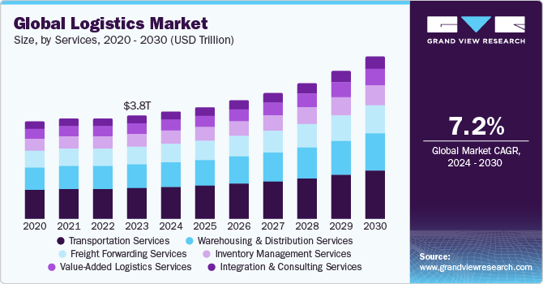

**Fig No 2.1 Estimated Growth Rate of Freight and Logistics Market in the World**

**2.3 Indian Scenario**

The Indian logistics sector is experiencing a profound, human-centric transformation, moving beyond just roads and warehouses to become the very bloodstream of the nation's burgeoning economy. This industry, which employs over 22 million people and is a vital cog in the 'Make in India' and e-commerce revolutions, is undergoing a governmental and technological overhaul. Initiatives like the PM Gati Shakti National Master Plan and the National Logistics Policy (NLP) are not just infrastructure projects; they are a concerted effort to weave together disparate transport modes road, rail, air, and waterways to bring down the crippling logistics cost from around 13-14% of GDP to a globally competitive single digit. This efficiency is meant to ease the life of the common trader, farmer, and, most importantly, the millions of workers on the ground.

The daily reality for the truck driver, the quintessential face of Indian logistics, remains a tapestry of grueling challenges and small victories. These drivers spend long hours away from home, battling poor road conditions, traffic congestion in dense urban centers, and the legacy of bureaucratic hurdles, even after the unifying implementation of GST. While new expressways and Dedicated Freight Corridors promise faster transit and less stress, the wait for these large-scale projects to fully materialize is long. For the driver, the true human cost of inefficiency is lost time, lower wages due to delayed turnaround, and immense physical strain. Yet, they remain the essential link, tirelessly ensuring goods reach every corner of a geographically diverse nation.

A major human opportunity lies in the burgeoning warehousing and last-mile delivery ecosystem. The e-commerce boom and the rise of quick-commerce platforms have created an unprecedented demand for modern, Grade-A warehouses and a vast army of delivery personnel. For young, semi-skilled individuals, this has opened up millions of formal job opportunities, often with better working conditions and technology training than traditional roles. However, this growth also brings challenges: the sheer pressure for "instant" delivery leads to demanding targets, and the last-mile rider faces risks like urban congestion, inaccurate addresses, and unpredictable weather, making their job intensely challenging and highly competitive.

Technology is the great equalizer, reshaping the career paths of countless logistics professionals. Digital platforms like the Unified Logistics Interface Platform (ULIP) are starting to connect various digital systems across the supply chain, enhancing transparency and predictability. For the small fleet owner or the warehouse supervisor, this means less time wasted on paperwork and more data-driven decision-making. However, this shift simultaneously creates a skill gap. The industry urgently needs digitally-literate workers who can manage IoT devices, operate automated warehouse systems, and analyze Big Data a necessity that underscores the need for massive investment in technical training and human resource development for the existing workforce.

Fragmentation is a deeply human problem in the Indian logistics landscape. The sector is still dominated by numerous small-scale, unorganized players, from independent truck owners to tiny local transport agencies. While this structure supports a dense network, it often leads to a lack of standardization, poor compliance, and difficulty in accessing formal credit or adopting new technology. The NLP and various reforms are pushing for formalization, but the transition is slow. For these small business owners, formalization offers stability and growth, yet it also means navigating a new, more compliant, and competitive environment, often requiring capital investment they can ill afford.

The push for a multimodal logistics network moving freight more onto rail and coastal shipping is not only an economic imperative but also a social and environmental one. Reducing the over-reliance on trucks lessens the load on highways, cuts fuel emissions, and potentially improves safety. The new Multi-Modal Logistics Parks (MMLPs), being developed across the country, are designed to be integrated centers where people can efficiently manage the shift from one mode to another. For the local community, these parks promise new hubs of commerce and skilled employment, transforming remote or semi-urban areas into strategic economic nodes, thereby impacting regional development and migration patterns.

Ultimately, the scenario in Indian logistics is one of massive, disruptive growth powered by human resilience and government vision. The objective, articulated by the government itself, is not merely to build roads but to increase the respect for labour and workers. By streamlining processes, formalizing the sector, and investing in modern infrastructure and skills, the aspiration is to move beyond the traditional image of a tough, unorganized industry. The true success of India's logistics revolution will be measured not just in reduced logistics costs, but in the improved daily life, dignity, and economic stability of the millions of people who keep the nation's goods moving.

**Table No 2.2: Indian Scenario of Logistics Industry**

| **Parameter** | **Details** |
| --- | --- |
| **Market Size** | $250 billion (2024 estimate) |
| **Contribution to GDP** | 13–14% of India’s GDP |
| **Employment** | 22+ million people |
| **Growth Rate** | 8–10% CAGR |
| **Major Segments** | Road (60%), Rail (30%), Air & Water (10% combined) |
| **Key Industries Served** | E-commerce, Manufacturing, FMCG, Agriculture, Pharma |
| **Top Logistics Hubs** | Mumbai, Delhi NCR, Bengaluru, Chennai, Kolkata, Ahmedabad |
| **Key Challenges** | High logistics cost, poor infrastructure, unorganized sector |
| **Government Support** | National Logistics Policy (2022), PM Gati Shakti, Bharatmala, Sagarmala |
| **Technology Trends** | Digitization, IoT, automation, real-time tracking, warehouse management |
| **Logistics Parks & Warehousing** | Rapid expansion, especially in Tier 2 & Tier 3 cities |
| **Future Outlook (2030)** | Expected to reach ~$380 billion with costs reduced to 8–10% of GDP |

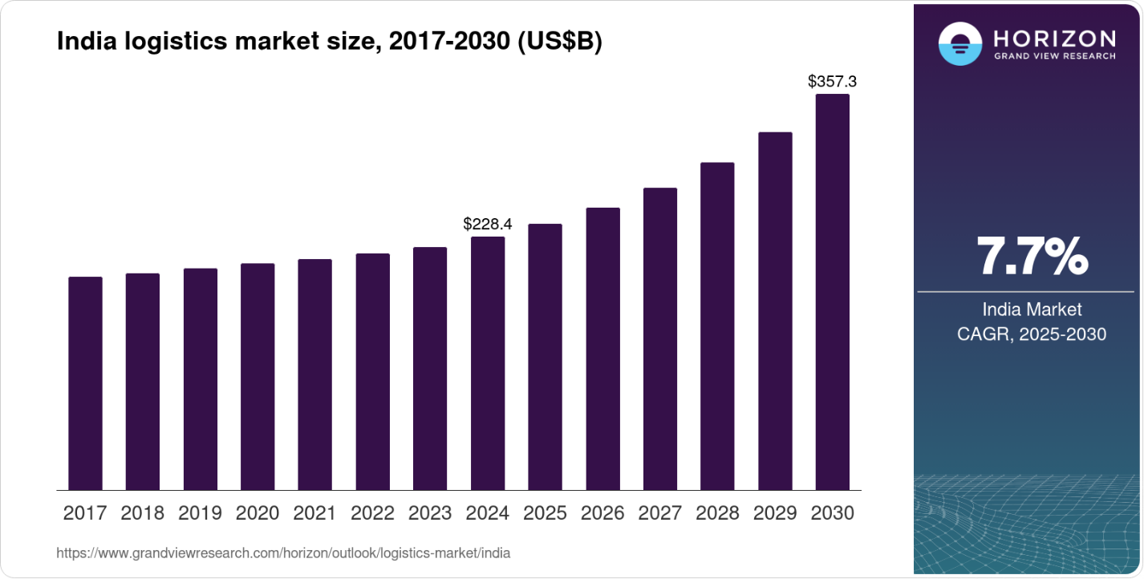

**Fig No 2.2 Estimated Growth Rate of Logistics Industry in India**

**2.4 Kerala Scenario**

The logistics scenario in Kerala is defined by unique geographical, demographic, and infrastructural factors that translate into a distinct human experience within the supply chain. Being a high consumption, geographically narrow, and densely populated state, its logistics challenges and opportunities are keenly felt by its workforce.

The Vizhinjam International Seaport development is the single greatest human centric disruption on the horizon. For the coastal communities and young workers of Thiruvananthapuram and Kollam, this project promises a massive injection of formal, skilled employment, crane operators, warehouse managers, IT technicians, and certified drivers. It is a transition from traditional, often unorganized labour to a modern, port led industrial ecosystem. The immediate human challenge is skilling and land acquisition, ensuring local populations are trained for these new roles and that the industrialization around the port is managed sensitively to benefit the community.

Kerala's status as a consumer state, heavily reliant on inbound logistics, places an immense burden on the truck drivers and warehouse workers managing goods entering the state. The narrow, densely settled nature of its terrain, combined with the legacy of smaller roads, means that drivers face greater stress from traffic congestion, slower turnaround times, and less effective use of their driving hours. The ongoing, large scale widening of National Highways (NH 66 in particular) is a direct response to this human problem, promising a future of faster, less stressful middle mile transport, which will improve the driver's work life balance and earning potential.

In the last mile delivery segment, the challenge is intensified by high population density and complex, often non standard urban/rural addresses. The delivery personnel, the face of the e commerce and quick commerce boom, are constantly battling the clock, navigating congested city lanes, and dealing with the physical strain of highly demanding delivery targets, all while providing the customer service expected in Kerala. This ecosystem, while creating a significant volume of jobs for the youth, requires better urban logistics planning and formal employment standards to mitigate the human cost of "instant" gratification.

The state's natural advantage lies in its extensive network of Inland Waterways (IWT). The effort to shift cargo, particularly bulky and Over Dimensional Cargo (ODC), onto barges via canals and rivers is not just a cost saving measure; it's a green logistics move that reduces the burden and pollution on the already crowded roads. For boatmen, dockworkers, and small scale freight forwarders near the waterways, this initiative offers a revival of an ancient trade and a pathway to more sustainable, environment friendly logistics careers.

Ultimately, the goal of Kerala’s logistics action plan, creating mini Multi Modal Logistics Parks (MMLPs), digital skilling programs, and focused initiatives on warehousing standards for unique state products like spices and seafood, is to transform a historically fragmented, road dominated system. The success of this transition will be measured by the improved skills, formalized employment, and better daily working conditions for the millions of people who form the backbone of the state's supply chain.

**Fig No.2.3 Kerala Logistics Scenario - Key Indicators**

| **Indicator** | **Description** | **Status/Trend** |
| --- | --- | --- |
| Major Ports | Cochin, Vizhinjam (upcoming) | High potential for cargo handling |
| Primary Mode | Road Transport | Dominant (over 70%) |
| Logistics Parks | Kochi, Kozhikode, Thiruvananthapuram | Developing phase |
| Challenges | Narrow roads, congestion | Moderate–High |
| Opportunities | Coastal shipping, IWT, E-commerce hubs | High |

**2.5 Driving Forces in The Logistics Industry**

Logistics isn't just about moving boxes; it's the human heartbeat of the global economy. It's the system that allows an Indian artisan's textile to reach a customer in Paris or a small business to access markets across the world, proving that Globalization and Trade Expansion truly make the world smaller.

The biggest pressure point and most visible change comes from us, the consumers. Thanks to E-commerce Growth, we now demand speed, affordability, and transparency. This shift is forcing logistics companies to radically reinvent the last-mile delivery experience, making the local delivery person one of the most vital, and often most pressured, links in the chain. They're backed up by Technological Advancements like AI for route planning and smart warehouses, which reduce human error and strain, making the entire process faster and less wasteful. This smart system is driven by Digital Integration, connecting everything from freight platforms to contracts to eliminate paperwork and increase trust.

In the physical world, massive Infrastructure Development (new ports, highways, and rail) is physically connecting communities and making the lives of truck drivers and port workers smoother. But these systems must now be built for the long haul. Following the chaos of the pandemic, companies are focused on Supply Chain Resilience, diversifying their networks and bringing sourcing closer to home to avoid future shocks, ensuring stability for both businesses and the workers who depend on them. Finally, a new ethical layer is emerging: Environmental Sustainability. Logistics firms are responding to climate concerns by investing in electric fleets and green warehouses, turning "green logistics" into a core business strategy rather than just PR. This shift aligns with Changing Consumer Behaviour, where people not only want fast delivery but also demand transparency and ethical responsibility in every part of the supply chain.

Ultimately, behind the complex data and infrastructure, logistics is a story about purpose. It's about ensuring a hospital gets its urgent supplies, a small business reaches a new market, and a family receives a much anticipated gift, proving the industry’s success is measured in connection and reliability, one delivery at a time.

**Fig No.2.4 Driving Forces in Logistics Industry – Global vs India**

| **Factor** | **Global Impact** | **Indian Impact** |
| --- | --- | --- |
| E-commerce Growth | High | Very High |
| Technology Integration | Advanced | Emerging |
| Infrastructure Investment | Mature | Expanding |
| Green Logistics | Increasing focus | Early stage |
| Workforce Skills | Automated and trained | Developing |

**2.6 Prospectus and Challenges**

The logistics industry is at a turning point, both globally and in countries like India. As the world becomes more connected, logistics is no longer just a support function, it's the backbone of commerce. With rising e-commerce, better infrastructure, and increased tech adoption, logistics is growing smarter, faster, and more crucial. There's room for innovation, new business models, and jobs for millions of people from warehouse workers to AI specialists.

**Key Prospects:**

The global logistics sector is undergoing a profound evolution driven by a mix of technology, consumer demand, and government focus.

The core change is the explosion of digital demands. E commerce Growth is the primary engine, creating massive, sustained demand for warehousing and last mile delivery, even reaching smaller towns. This surge is only possible because of Digital Transformation, which uses AI based route planning and real time tracking to ensure speed and accuracy, turning what was once a manual, error prone process into a smart system.

The physical infrastructure must keep pace with the digital demand. Governments globally are heavily focused on Infrastructure Investment, building better ports, highways, and multimodal hubs to streamline the movement of goods over long distances. Concurrently, Global Trade Expansion means these improved networks are connecting more emerging markets into the world's supply chains, raising the need for seamless international operations.

This industry transformation is a huge Employment Generation engine, creating millions of jobs accessible to youth at every skill level, from delivery drivers to drone operators. The increasing complexity of the supply chain is also driving the Rise of 3PL and 4PL Providers, specialized expert firms to whom businesses outsource their logistics needs, leading to market specialization and growth.

Finally, the industry is increasingly defined by its social and environmental responsibility. Green Logistics has become a critical trend, driven by demand for sustainable practices like electric vehicles and solar powered warehouses. This focus on sustainability and the push for Growth in Rural Reach means logistics is not just an economic necessity, but a powerful tool for social inclusion, connecting every community to the global market while reducing its environmental footprint.

While the outlook is promising, the path is not without obstacles. The logistics industry faces several roadblocks; some technical, some infrastructural, and some deeply human. It’s an industry that runs 24/7, often in tough conditions, and even a small error or delay can ripple through entire supply chains.

**Key Challenges:**

The challenges facing modern logistics are deeply rooted in economic, infrastructural, and human factors.

The most persistent hurdle is High Operational Costs, driven by volatile fuel prices, various tolls, and taxes. This is often made worse by Infrastructure Gaps, as many regions still grapple with poor quality roads, inadequate port facilities, and a shortage of modern warehousing space.

The human element of the challenge lies in the nature of the industry itself. A significant portion of the sector is defined by Unorganized Sector Dominance, where informal operators lack the standardization and compliance of larger firms. This fragmentation is compounded by a crucial Lack of Skilled Workforce. Many workers lack the training to manage the automated warehouses, digital tracking, and advanced systems now used by major companies, highlighting a severe skill mismatch.

Technology presents a dual challenge. While large firms are digitally advanced, smaller providers are hindered by Technology Gaps, relying on outdated, manual processes which slows down the entire supply chain. These operational difficulties are further tangled by Regulatory Hurdles, where complex customs, varied interstate taxes, and excessive documentation create costly, time consuming bottlenecks for every shipment.

Finally, the most visible daily struggle is the Last Mile Delivery Challenge. In dense urban areas, narrow lanes, heavy traffic, and inaccurate addresses make the final step of delivery difficult, costly, and highly stressful for the delivery personnel. Overlaying all of this is the growing demand for Sustainability Pressures, forcing companies to find ways to balance the consumer's demand for speed and convenience with the urgent need for eco friendly operations.

Hence logistics is about people those who plan, package, drive, load, track, and deliver. It's an industry powered by early risers, night shifters, and last-mile heroes who bring the world closer, one delivery at a time. The future of logistics is not just in automation or AI: it’s in building an ecosystem where technology supports people, where businesses big and small can thrive, and where every shipment tells a story of human connection and care.

**2.7 Pestel Analysis**

1. **Political Factors**

The logistics industry is constantly shaped by the highest levels of government and international politics, demonstrating that a smooth supply chain depends as much on policy as it does on pavement.

The most direct influence comes from Government Infrastructure Policies. Massive national programs, like Bharatmala and Sagarmala in India, represent significant state investment in highways, ports, airports, and railways. These projects directly determine how fast and efficiently goods can travel, fundamentally improving logistics efficiency across the entire economy.

Beyond national borders, the movement of goods is governed by international relationships. Trade Agreements and Tariffs, such as those created by the WTO or through Free Trade Agreements (FTAs), dictate the cost and ease of cross border logistics. A simplified or tariff free zone immediately makes the job of international shippers and truckers much easier. Closely related are Customs Regulations; political will to simplify and digitize these clearance processes is crucial. When a government streamlines documentation and inspections, cargo moves faster, reducing delays and costs for everyone involved.

Finally, the entire global network is sensitive to global political realities. Political Stability is a non negotiable factor. Instability, whether from wars, major strikes, or geopolitical conflicts in vital transit areas like the Red Sea or Ukraine, can instantly disrupt the most optimized global supply chains, forcing logistics professionals to find costly and complex alternative routes.

1. **Economic Factors**

The performance and stability of the logistics industry are profoundly linked to broader economic and human market dynamics.

Transportation costs are primarily dictated by external economic pressures, chief among them being Fuel and Energy Prices. As global oil prices rise and fall, the operational costs for trucks, ships, and planes change directly, which immediately impacts profit margins across the industry. This cost sensitivity is matched by the demand side, where GDP Growth and Trade Volume act as the main drivers. A strong economy and high trade activity boost the need for logistics services, creating greater demand for both domestic delivery and international shipping.

Furthermore, economic volatility introduces risk. Inflation and Currency Fluctuation can significantly affect the sector. High inflation increases the cost of purchasing and maintaining equipment, while changes in exchange rates affect the pricing of imports and exports, adding complexity to global operations. The human cost of logistics is seen in Labor Costs and Availability. A persistent challenge is the shortage of skilled personnel, such as experienced truck drivers and trained warehouse managers. When labour is scarce, it leads to delays in shipments and an upward pressure on wages, ultimately raising overall operational costs.

1. **Social Factors**

The social and demographic changes of our time are powerfully reshaping the daily realities of the logistics industry.

The dominant force is the shift in where and how people live and shop. Driven by Urbanization and Consumer Expectations, people in cities now demand incredibly fast delivery times, forcing logistics companies to totally rethink the last-mile process. This is amplified by the persistent Rise of E-commerce, which means more packages are moving to more places, creating a consistently high volume for the entire network, including remote areas.

This increased demand directly impacts the people in the supply chain. Workforce Trends are putting a greater focus on the human element, calling for better work-life balance, improved safety, and gender inclusion for truckers and last-mile delivery workers who often face grueling conditions.

Finally, changes in what people consume are creating new logistical challenges. Changing Lifestyle and Habits, particularly the focus on health and fresh goods, has increased the need for complex, reliable cold-chain logistics, necessary for safely transporting everything from fresh food to vital vaccines.

1. **Technological Factors**

Technology is the primary disruptor and engine of efficiency across modern logistics.

The physical processes are being transformed by Automation and AI. This includes the widespread adoption of smart warehousing and robotics for faster inventory handling, alongside AI driven route optimization that determines the most efficient path for every shipment. This revolution in speed is supported by Tracking and Visibility Tools. Technologies like real time GPS, IoT sensors, and RFID tags provide complete transparency, allowing both companies and customers to know the exact location and condition of their goods at all times.

The administrative and commercial side of the industry is being streamlined by Digital Platforms. Online freight marketplaces and sophisticated logistics management systems are improving coordination, reducing the need for manual paperwork, and boosting the overall efficiency of booking and managing shipments.

Finally, new hardware is fundamentally changing delivery methods. The introduction of Electric Vehicles and Drones offers cleaner, more cost effective options for last mile delivery. These emerging technologies are crucial for reducing fuel costs and environmental impact, particularly in crowded urban areas.

1. **Environmental Factors**

Environmental factors have moved from being a side concern to a central strategic driver for the logistics industry.

The industry's impact on the planet is unavoidable, starting with Carbon Emissions and Pollution. Since transportation contributes significantly to global emissions, there is immense pressure on companies to adopt cleaner practices, such as switching to electric vehicles and optimizing routes to use less fuel. This focus on sustainability extends to how goods are wrapped, driving demand for Sustainable Packaging to reduce reliance on plastic and shift toward biodegradable or easily recyclable materials.

Beyond the industry's own impact, it must contend with the effects of a changing environment. Climate Change Risks are increasingly disrupting operations, as extreme weather events like floods, prolonged heatwaves, and severe storms directly interrupt shipping routes and threaten the integrity of warehouse facilities.

This push and pull of environmental concern and operational risk is formalized through policy. Government Regulations are directly shaping business strategy with the introduction of measures like carbon taxes, strict emission norms, and green logistics certifications, forcing the sector to prioritize ecological responsibility alongside efficiency.

1. **Legal Factors**

The modern logistics sector is increasingly defined by a complex web of legal and regulatory requirements designed to protect workers, data, and intellectual property.

A major focus is placed on the people who operate the system, governed by Labor and Safety Laws. Regulations are becoming stricter regarding driver working hours, mandatory safety equipment, and comprehensive insurance to ensure the well-being and security of truckers and delivery staff.

As the industry embraces digital transformation, new challenges arise concerning information. Data Protection Laws, such as GDPR, directly affect how logistics companies handle and store sensitive tracking and customer data across borders. Compliance with these privacy statutes is a non-negotiable part of modern operations.

On the operational side, compliance with numerous permits is a constant challenge. Licensing and Compliance requirements for transport, warehousing, and specific types of cargo vary widely by country and region, requiring significant administrative effort. Furthermore, as technology development accelerates, the use of proprietary AI, tracking apps, and logistics software is governed by Intellectual Property in Tech Logistics laws, ensuring that companies comply with software licensing and patent regulations.

The logistics industry operates in a highly dynamic environment shaped by global politics, economic pressures, consumer behavior, and rapid tech innovation. A successful logistics company must stay agile, embrace sustainability, and adapt to regulatory changes while never losing sight of the people who move the world, every day.

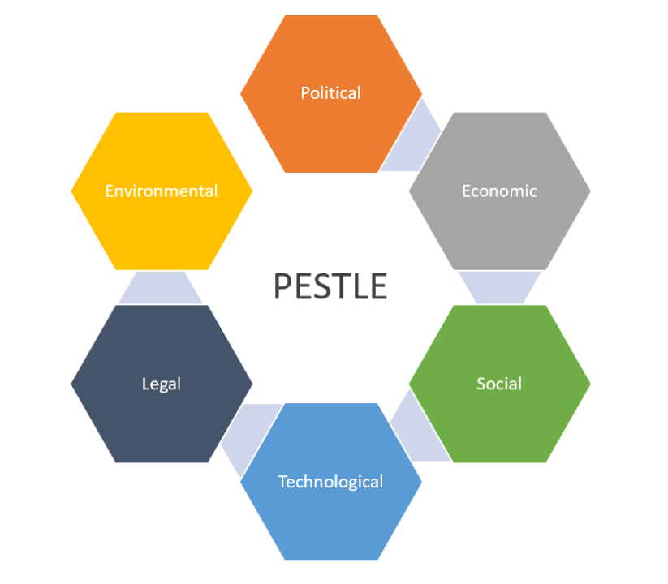

**Fig No 2.3: PESTEL Analysis**

**2.8 Industry Competitive Analysis**

The logistics industry is vast and varied, covering everything from global freight to neighborhood last-mile deliveries. The competition ranges from large multinationals like DHL and FedEx, to homegrown startups solving hyperlocal delivery challenges. In India, players like Delhivery, Blue Dart, and Ecom Express have emerged as leaders, while global giants like Amazon and Maersk continue to expand their footprint. The competition is fierce because the industry touches almost every sector; retail, manufacturing, healthcare, agriculture and every delivery must be both fast and affordable.

In the fast paced world of logistics, time is everything. Companies that consistently deliver on time earn customer trust and repeat business. Predictable delivery windows aren't a luxury; they are critical operational needs, especially in sensitive industries like healthcare, retail, and e commerce. Success, however, isn't just about speed. This is a high volume, low margin business where customers are incredibly price sensitive and compare rates closely. Even small cost differences can drive large decisions, particularly in bulk shipping and business contracts.

To maintain both speed and competitive pricing, successful firms must leverage a strong Technology Advantage. Automation, AI, and real time tracking are no longer optional; they help companies streamline operations, reduce errors, and dramatically improve the customer experience. Tech savvy firms lead the pack by offering greater transparency and faster service. Equally important is a wide and deep Network Reach. A company that can efficiently connect both busy urban centers and remote areas, especially in large countries, gains a competitive edge by being truly accessible to every part of the market.

Yet, even the best technology and widest network aren't enough when problems inevitably arise. When things go wrong, customers expect fast, human help. Logistics firms with strong Customer Service teams retain clients better and build those vital long term relationships. Looking ahead, Green logistics is emerging as a powerful competitive differentiator. Eco conscious consumers and corporate clients increasingly prefer companies that embrace a Sustainability Focus, using electric vehicles, recyclable packaging, or carbon neutral shipping methods. Finally, the ability to handle sudden spikes is crucial. Whether it's a festive season surge or unexpected global supply chain demands, Scalability and Flexibility in infrastructure, staffing, and dynamic routing are essential tools for survival and continuous growth.

**Porter’s Five Forces: Logistics Industry**

The logistics industry operates under intensely competitive pressure, primarily driven by Very High Industry Rivalry. This market is incredibly fragmented, housing everything from global titans like FedEx and DHL to countless regional and niche providers. This high competition frequently boils over into aggressive price wars and undercut bids. Differentiation is difficult; service offerings often look similar, making reliable execution and superior technology the few areas left to stand out. Consequently, customer retention is challenging as contracts are frequently rebid, and clients are always ready to switch for a better deal.

The industry also faces a High Bargaining Power of Buyers. Large customers, such as major manufacturers or big box retailers, possess tremendous leverage and can negotiate significantly better rates due to the sheer volume they offer. Furthermore, the switching costs are low for buyers; with so many providers available, customers can easily move their business based on price, reliability, or service quality. This is compounded by the fact that all customers are inherently price sensitive, constantly pushing logistics firms to offer highly competitive pricing just to stay in the game.

Adding to the complexity is the Moderate to High Threat of New Entrants. While there are moderate barriers to entry initial capital investment in vehicles, warehouses, and technology is significant it's not insurmountable. Newcomers must contend with established players who have built powerful brand loyalty and relationships over decades. Any new firm must invest heavily to compete, as digital platforms, sophisticated tracking systems, and automation are rapidly becoming the standard. They must also navigate complex and often costly regulatory compliance relating to environmental and safety standards.

The industry's relationship with its suppliers presents a Low to Moderate Bargaining Power of Suppliers. When it comes to fuel, vehicles, and equipment, logistics firms have numerous options, which naturally drives down the power of any single supplier. However, power shifts when discussing labour. Skilled professionals, particularly truck drivers and warehouse operators, can be scarce during peak seasons, giving more leverage to labour unions or recruitment agencies. Similarly, dependence on specialized logistics software and automation solutions can give technology providers more leverage, especially where switching to a different tech platform would be costly.

Finally, the Threat of Substitutes is Moderate. Customers always have alternative ways to move goods, as alternative transport modes (air, rail, sea) can substitute for road transport depending on the needed balance of speed versus cost. Furthermore, a major threat comes from in-house logistics, where some large manufacturers opt to develop their own capabilities rather than rely on third-party providers. In the long term, digital substitutes like 3D printing, while not a direct replacement for transport, could reduce the total volume of physical goods that need shipping, impacting demand across the board.

**CHAPTER 3**

**COMPANY PROFILE**

**3.1 Promoters/Ownership Pattern and Legal Framework**

Delman Shipping LLC is a privately held logistics company based in Dubai, UAE. As a private entity, it does not publicly disclose detailed shareholder information. However, available records indicate that the company is led by Ug Thottappilly Menon, who serves as the Managing Director and CEO.​

Additionally, Ug Thottappilly Menon is listed as a director of Delman Logistics Private Limited, an Indian company incorporated on April 10, 2023, in Thrissur, Kerala. The other directors of Delman Logistics are Thottappilly Unnikrishnan and Krishna Nivas Gopalakrishnan Greeshma.

The legal foundation of Delman Shipping LLC is firmly rooted in the United Arab Emirates, where it is incorporated and operates. As a Limited Liability Company (LLC), it benefits from a flexible corporate structure common in the UAE, providing essential liability protection to its shareholders. The company is officially registered and licensed under the Dubai Department of Economic Development (DED), ensuring its adherence to the comprehensive Commercial Companies Law of the UAE.

Delman’s operational credibility is reinforced by its extensive trade and industry compliance certifications. It holds accreditation from the General Civil Aviation Authority (GCAA) for air freight, is IATA CASS certified for air cargo agent financial settlements, and is a member of FIATA, signifying its compliance with global freight forwarding standards. Furthermore, it maintains ISO Certification, demonstrating a commitment to quality and safety management systems. In all its operations, the company strictly observes both UAE Customs regulations and the complex international shipping laws that govern land, air, and sea freight. Given its reach, the company must also comply with the respective import and export laws, maritime law, and international logistics conventions of the many countries it serves.

Client trust is safeguarded through rigorous adherence to UAE data protection laws, particularly in the confidential handling of personal and shipping information. The company also maintains high Environmental and Safety Standards, complying with both national UAE laws and international guidelines for hazardous goods handling. Regarding its structure, Delman Shipping must adhere to the UAE's specific Ownership Regulations for Foreign Investors, which historically required a local Emirati partner outside of free zones, though these rules have been increasingly relaxed in recent years to encourage foreign investment.

The well being of its workforce is governed by the UAE Labour Law (Federal Decree Law No. 33 of 2021). The company is responsible for providing legal employment contracts, fair wages, health insurance, and mandated end of service benefits. For resolving disagreements, the Dispute Resolution Mechanism typically involves the Dubai Courts or arbitration, depending on the contract's terms. Cross border disputes involving international shipments may also be subject to global arbitration. Finally, Delman protects its interests and those of its clients through robust Insurance and Liability Coverage, including freight, public liability, and cargo specific policies in line with shipping regulations. Its core Contractual Obligations are structured around Incoterms (International Commercial Terms), which legally define the responsibilities of both buyers and sellers in all international trade agreements.

**3.2 History and Growth**

Delman Shipping LLC was founded in 2010 in Dubai, a city rapidly transforming into a global logistics powerhouse. At the time, global supply chains were becoming increasingly complex, and the UAE was positioning itself as a central hub between East and West. In this fast-changing environment, Ug Thottappilly Menon, a logistics professional with a vision, laid the foundation for Delman. He started with a simple goal: to provide dependable, transparent freight forwarding solutions tailored to each client’s needs.

In its early days, Delman operated with a lean team, offering freight forwarding, customs clearance, and basic cargo handling. What set it apart, however, was its unwavering commitment to customer service. Word-of-mouth referrals began to spread, particularly among SMEs and trading houses in the region. Delman was seen not as just another logistics provider, but as a trusted partner that got things done on time, every time.

As the company’s reputation grew, so did its ambitions. By 2015, Delman expanded its services into more specialized areas such as hazardous cargo handling, international relocation, and warehousing. This move wasn’t just strategic; it reflected the evolving needs of its clients. Delman invested heavily in staff training and certifications, including ISO and IATA accreditations, to ensure safety and compliance were at the core of operations.

By the late 2010s, Delman was handling freight not only within the GCC but also across Asia, Europe, and Africa. Its presence grew through a network of trusted international agents, and the company’s name became known in major trade corridors. With Dubai as its anchor point, Delman facilitated complex logistics projects spanning continents whether it was air freight to Nairobi or sea shipments to Rotterdam.

Recognizing that logistics was becoming increasingly digital, Delman began modernizing its operations in the early 2020s. The company implemented freight management software, streamlined its documentation processes, and adopted online booking and tracking systems. This shift not only improved efficiency but also gave clients real-time control over their shipments; something that was especially vital during the COVID-19 pandemic, when agility and transparency became non-negotiable.

In 2023, Delman took a major strategic step by establishing Delman Logistics Pvt. Ltd. in India. With roots in Kerala and a leadership team familiar with South Asian markets, this move allowed the company to tap into one of the world’s fastest-growing logistics sectors. The Indian branch strengthened Delman’s cross-border capabilities and reflected its founder’s dual commitment to his home region and the global stage.

Today, Delman Shipping LLC is more than a logistics company it’s a relationship-driven brand built on trust, resilience, and personal service. From a modest office in Dubai to operations across six continents, the journey has been shaped by real people, real challenges, and a relentless focus on doing right by customers. Led by Ug Thottappilly Menon and his team, Delman continues to grow not just in size, but in purpose.



**Fig No 3.1 Delman Shipping LLC LOGO**

The journey of Delman Shipping LLC began in 2010 with its foundation, establishing a presence in the competitive UAE logistics market. Showing a quick readiness to grow, the company rapidly diversified its core business just two years later in 2012 by strategically expanding into Land, Sea, and Air Freight operations. This early move positioned Delman as a comprehensive multi modal logistics provider. By 2015, the firm took on more specialized challenges, making a deliberate entry into the niche areas of Hazardous Cargo and Project Logistics, demonstrating its capability to handle complex and high value shipments.

The company's commitment to quality and international standards was formally recognized in 2017 when it achieved key accreditations, earning both ISO and IATA CASS Certifications. Two years later, in 2019, Delman significantly broadened its operational reach by focusing on the Expansion of its Global Partner Network, laying the groundwork for more extensive international services. A true test of resilience came in 2020 with the global supply chain disruption caused by the COVID 19 Pandemic. Delman successfully managed to adapt its operations, ensuring continuity for its clients during an unprecedented time.

The growth trajectory continued into the new decade with a significant milestone in 2023 when the company formally expanded its corporate footprint by incorporating Delman Logistics Pvt. Ltd. in India. This move cemented its presence in one of the world's largest and fastest growing logistics markets. This sustained growth and proven reliability culminated in 2024 with the company being formally recognized across the industry as a Trusted Global Logistics Partner.

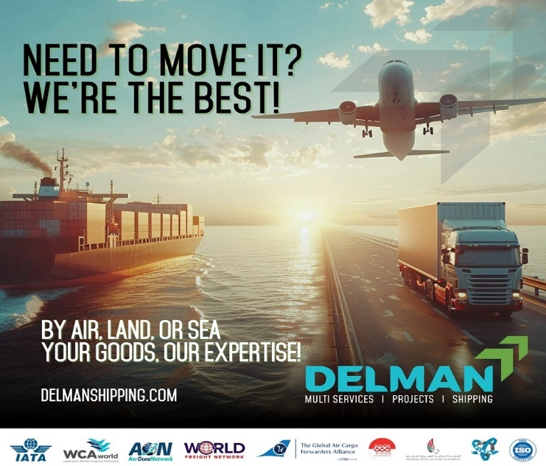

**Fig No 3.2 Delman Shipping Business Model**

**3.3 Mission and Vision of Delman Shipping**

**3.3.1 Mission Statement**

Delman Shipping LLC is dedicated to providing innovative, dependable, and customer-focused logistics solutions that bridge global markets with efficiency and care. Our mission is to simplify the complexities of international freight by delivering tailored services across land, sea, and air, while upholding the highest standards of professionalism, compliance, and ethical conduct. Through strategic partnerships, cutting-edge technology, and a passionate team, we aim to be a trusted logistics partner that drives success for our clients and contributes positively to the global supply chain.

**3.3.2 Vision Statement**

Delman Shipping LLC envisions becoming a globally recognized leader in integrated logistics and freight solutions, known for reliability, innovation, and customer excellence. We aspire to connect businesses across continents with seamless, sustainable, and technology-driven supply chain services. Our vision is to redefine the logistics experience by building a network that delivers not just cargo, but confidence enabling our clients to grow beyond borders while we evolve as a trusted name in global trade

**3.4 Structure of the Organization**

Delman Shipping LLC operates with a lean yet highly coordinated organizational structure that emphasizes agility, expertise, and accountability across every layer of the business. At the helm is Ug Thottappilly Menon, the Managing Director and CEO, whose leadership blends strategic vision with hands-on industry experience. Reporting directly to him are department heads overseeing key verticals; Operations, Sales & Client Relations, Finance, Customs & Compliance, and IT & Digital Solutions. Each unit is led by seasoned professionals who not only bring technical skill but a deep understanding of customer expectations in global logistics.

The Operations Team, often considered the company’s engine room, manages day-to-day shipments, warehouse coordination, and freight scheduling, while the Sales and Customer Service Team ensures clients feel heard, supported, and informed. The Finance Department maintains fiscal discipline and transparency, while the Compliance Team ensures that all shipments adhere to international laws, certifications, and customs regulations. Supporting this structure is a growing team of logistics coordinators, drivers, and warehousing staff—many of whom have been with Delman for years and take pride in being part of a company that treats them like family. Together, this tight-knit yet globally focused team forms the backbone of Delman Shipping, united by a shared commitment to excellence and a human approach to logistics.

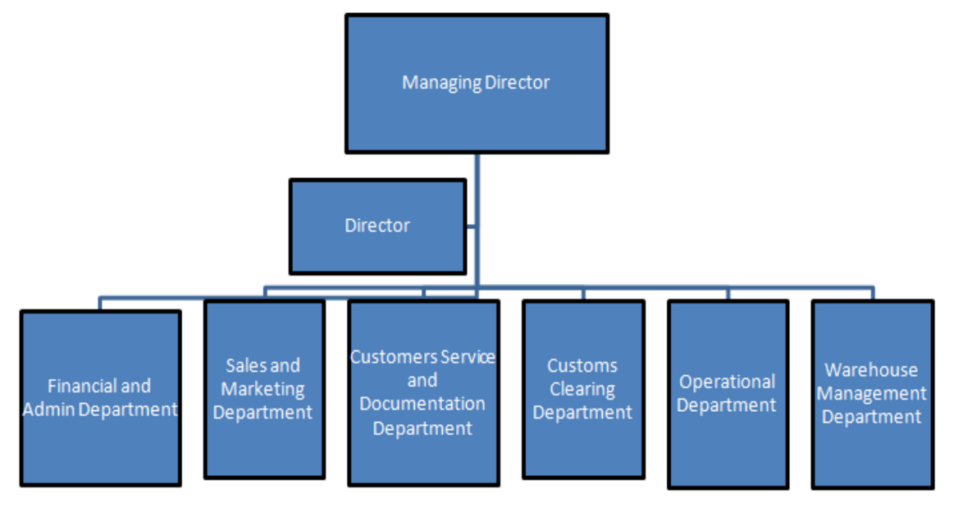

**Fig 3.3 Departmental Structure of Delman Shipping**

The departments in Delman Shipping are:

1. Operational Department
2. Sales and Marketing Department
3. Customer Service and Documentation Department
4. Customs Clearing Department
5. Finance and Admin Department
6. Warehouse Management Department

**3.5 Service Profile**

Delman Shipping LLC offers a personalized, end-to-end logistics experience built on trust, precision, and global reach. From air freight that moves urgently needed goods across continents to sea freight that carries bulk shipments reliably, Delman ensures every cargo is handled with care and expertise. Their services span land transportation across the GCC, hazardous cargo handling, international relocations, customs clearance, and warehousing. Backed by a dedicated team and a client-first mindset, Delman doesn’t just move goods, they move businesses forward with seamless, human-centered logistics solutions.

**Fig.No.3.1 Delman Shipping LLC - Key Services Portfolio**

| **Service** | **Mode** | **Description** |
| --- | --- | --- |
| Sea Freight | FCL & LCL | Port-to-port and door-to-door services |
| Air Freight | IATA Certified | Urgent cargo movement |
| Land Transport | GCC & Local | Reliable trucking network |
| Warehousing | Bonded & Climate-controlled | Storage and distribution |
| Project Logistics | Specialized | Heavy and oversized cargo |
| Customs Brokerage | End-to-end support | Clearance and documentation |

**3.5.1 Services**

1. **Sea Freight Services**

Delman Shipping offers both Full Container Load (FCL) and Less than Container Load (LCL) services, catering to businesses of all sizes. Whether you're a small trader shipping a few pallets or a multinational moving entire containers, Delman coordinates your ocean freight from port to port or even door to door. Their team handles booking space on vessels, customs documentation, container packing, and real-time tracking. They also manage special shipments like oversized cargo or breakbulk freight. With their hands-on service, clients feel like they’re navigating international waters with a skilled crew at the helm.

1. **Land Transportation (GCC & Local)**

Delman runs a dependable fleet of trucks across the UAE and GCC countries, ensuring cargo moves efficiently by road. They handle everything from small loads to oversized machinery, and even provide temperature-controlled options if needed. With experienced drivers and route planners, Delman minimizes delays and keeps shipments safe. For customers, it feels like having a logistics partner that knows every turn, checkpoint, and shortcut in the region.

1. **Project Cargo Logistics**

Project logistics is where Delman shines in complexity. Think of transporting heavy construction equipment to a remote site or moving an entire factory’s components. Delman handles route surveys, equipment like cranes and flatbeds, permits, and on-site coordination. Clients trust them with mission-critical logistics because they plan every detail with military-like precision while staying flexible enough to adapt on the ground. It's not just freight; it's a full-scale operation.

1. **Air Freight Services**

When time is of the essence, Delman's air freight services ensure your cargo gets where it needs to go fast. Whether it’s medical equipment, electronics, or high-value goods, they manage the full process: from pick-up and air booking to customs clearance and delivery. They are IATA-certified, meaning they follow the strictest global standards. Clients appreciate the speed, but even more so, they value the constant updates and personal attention that makes urgent shipments feel manageable even during high-pressure situations.

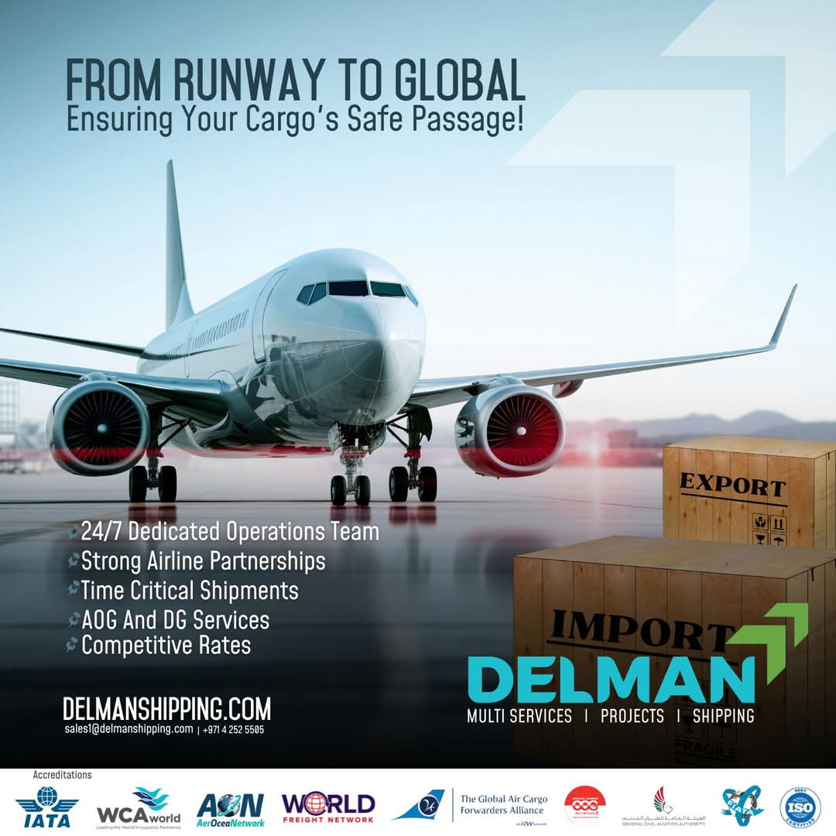

**Fig No 3.4 Air Freight Services of Delman Shipping**

1. **Hazardous Cargo Handling**

Transporting dangerous goods requires strict compliance and specialized knowledge, and Delman is fully certified (IMDG, IATA DGR) to handle such cargo safely. This includes chemicals, flammable materials, and industrial gases. From proper labelling and packaging to securing the right permits, Delman ensures every regulation is followed to the letter. Their clients, particularly in the oil, gas, and chemical industries, rely on them for a safe and compliant experience no shortcuts, no compromises.

1. **Customs Clearance & Brokerage**

International trade involves a mountain of paperwork commercial invoices, bills of lading, import permits, and more. Delman takes that burden off your shoulders. Their in-house customs brokers navigate UAE and international regulations with ease, ensuring that shipments clear quickly and legally. Whether it’s a last-minute shipment or a complex import project, clients value Delman’s ability to get things moving without bureaucratic delays.

1. **Warehousing & Distribution**

Delman provides modern, secure warehouse space for both short-term storage and long-term inventory holding. This includes climate-controlled areas, bonded storage, and fulfilment support. They also help with order picking, packing, and local delivery. For clients running lean operations or expanding into the region without physical infrastructure, Delman becomes an extension of their business, handling backend logistics so they can focus on growth.

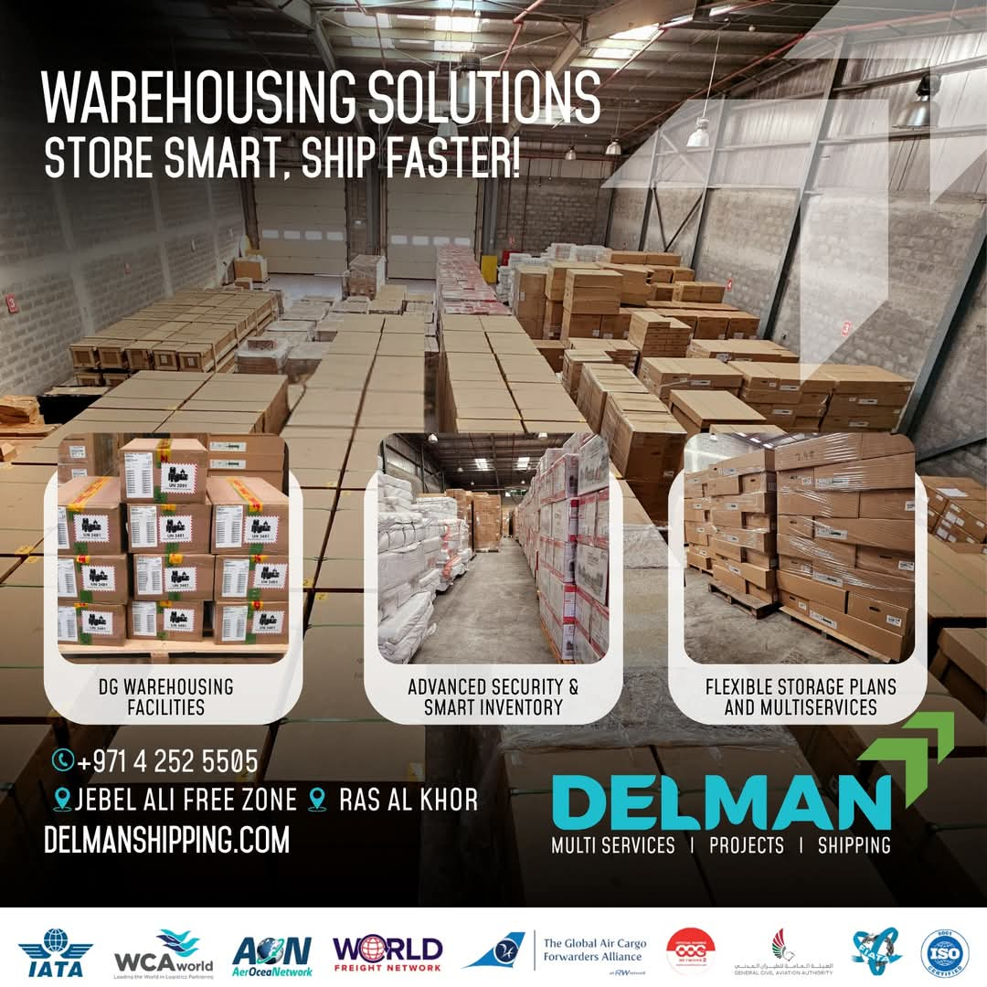

**Fig No 3.5 Warehousing Facilities of Delman Shipping**

1. **International Relocation Services**

For individuals and families moving internationally, Delman offers a complete relocation solution. They pack, crate, ship, and clear personal effects ensuring everything arrives safely and on time. From cherished family heirlooms to fragile electronics, Delman’s moving experts treat every item with respect and care. They also assist with customs formalities and destination services, making what is usually a stressful process feel smooth and predictable.

1. **Freight Insurance**

Shipping cargo always involves some risk delays, damage, theft, or natural disasters. Delman helps clients minimize exposure by offering tailored insurance coverage that protects goods throughout the supply chain. They assist in claim handling too, acting as your advocate when things go wrong. For many clients, this peace of mind is worth more than the policy itself.

1. **E-commerce & Cross-Border Fulfilment (Emerging Service)**

With the rise of online selling, Delman is expanding its services to support e-commerce brands. They offer storage, pick-and-pack, order fulfilment, and cross-border delivery especially between the UAE, India, and the GCC. For small to mid-sized online sellers, Delman acts as a silent logistics partner behind every click-to-delivery journey, helping them scale without having to invest in their own infrastructure.

1. **Cross-Trade Shipping**

Delman facilitates cargo movement between two foreign countries without passing through the UAE. For example, a client in India can ship goods directly to Kenya via Delman’s network, while Delman coordinates everything from documentation to delivery offering true global reach without geographic limitations.

1. **Documentation & Legalization Support**

International shipments often require complex documentation—certificates of origin, commercial invoices, consular legalization, chamber attestations, etc. Delman provides end-to-end document processing to ensure compliance with destination country regulations, helping clients avoid delays or penalties.

1. **Supply Chain Consultation**

Delman works closely with businesses to streamline their supply chains. This includes optimizing shipping routes, choosing the right mix of freight modes (sea/air/land), and improving cost efficiency. This consultative approach turns Delman into a logistics advisor not just a service provider.

1. **Packing, Crating & Labelling Services**

Delman offers professional packing and crating especially for fragile, hazardous, or heavy equipment. They also ensure shipments meet international labelling standards, which is critical for customs compliance and safety, particularly in air and sea freight.

1. **24/7 Cargo Tracking & Customer Support**

With advanced tracking tools and a responsive service team, Delman gives clients visibility into their cargo movement around the clock. Whether it’s a midnight delivery query or a customs update, clients know help is just a call or email away.

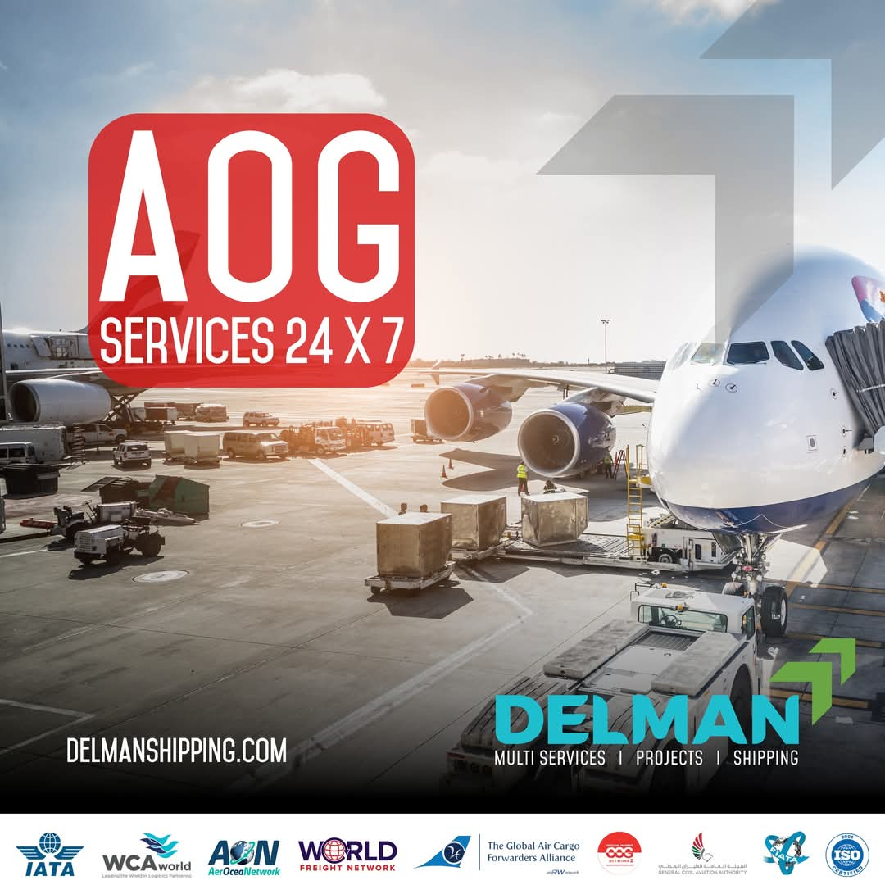

**Fig No 3.6 24/7 AOG Services of Delman Shipping**

**3.6 Competitors**

1. **Aramex Delivery Limited**

Aramex is one of the most recognizable names in Middle Eastern logistics, often seen as the go-to for express shipping and e-commerce deliveries. With a vast infrastructure and global reach, they cater to both individuals and businesses. While Delman focuses on personalized freight solutions, Aramex leans into scale and speed. Their tech-driven systems are impressive, but some smaller clients may find Delman’s hands-on, boutique-style service more tailored to their needs.

1. **Transworld Group**

Transworld is a logistics giant with deep roots in shipping, particularly in the India–UAE corridor. Known for vessel ownership and large-scale project handling, they’re a powerhouse when it comes to end-to-end marine logistics. Compared to Delman, which is more agile and relationship-driven, Transworld plays in the major league but often lacks the intimacy of a company that knows your name, not just your container number.

1. **Gulftainer**

A leader in port operations and terminal management, Gulftainer operates behind the scenes where ships are loaded and unloaded. Their logistics arm supports large industrial movements, particularly for government and energy sectors. For clients with massive cargo or port-specific needs, they’re a strong contender. Delman, meanwhile, is better suited for companies looking for flexible solutions, fast communication, and high adaptability.

1. **Globelink West Star Shipping LLC**

This company has carved out a niche in handling fragile, auto, and exhibition cargo serving industries that require careful planning and delivery. Their network is broad, and they’re known for attention to detail. In many ways, Globelink and Delman share a customer-focused DNA, though Delman’s strength lies in treating every shipment like a personal project, especially for SMEs and niche markets.

1. **STALCO – Shipping Trading & Lighterage CO LLC**

STALCO is a well-established freight forwarder with over 40 years in the UAE. Their experience is their strength, they know the regulations, have seen market shifts, and offer stable, time-tested services. However, their traditional structure can sometimes be less responsive than Delman’s agile setup. Clients looking for quicker decision-making and real-time flexibility often find Delman more approachable and responsive.

1. **Jenae Logistics**

Jenae is a solid mid-sized player offering a wide range of services. They’re efficient, cover all freight modes, and provide good customer service. They appeal to clients who want a “one-stop-shop” solution. However, Delman differentiates itself by digging deeper into custom needs such as cross-border setups, high-touch relocation services, or complex hazardous cargo handling where Jenae tends to offer more standard packages.

**3.7 Future Plan**

As Delman Shipping LLC looks to the future, their vision revolves around expanding their service offerings to better meet the ever-evolving needs of global trade. The company plans to strengthen its position by integrating advanced technology to improve efficiency in tracking, communication, and overall logistics management. Delman recognizes that staying ahead means embracing innovation, and they’re already exploring next-gen solutions, like automated warehouses and AI-powered shipment tracking, to give clients real-time visibility and peace of mind. The goal is to make the shipping process feel as seamless and transparent as possible for every customer.

Delman also sees the growth of e-commerce as a major driver of its future success. With online shopping booming globally, they’re working on enhancing their cross-border fulfillment capabilities, particularly focusing on the UAE-India route, which is a key market for them. Delman plans to invest in streamlined warehousing and inventory management systems, helping e-commerce businesses expand rapidly while ensuring that customer orders are fulfilled quickly and accurately. For their clients, this means fewer headaches and faster deliveries critical for staying competitive in a fast-paced digital world.

As the world shifts toward more sustainable logistics, Delman Shipping is committed to reducing its environmental impact. They plan to integrate eco-friendly solutions into their operations, from adopting more fuel-efficient transportation modes to exploring the use of electric vehicles for local deliveries. Their sustainability efforts are more than just a response to market demand; it’s about creating a greener future for generations to come. Delman is fully aware that businesses today want partners who align with their values, and they’re taking proactive steps to build a more sustainable logistics network.

In the coming years, Delman plans to expand its geographical footprint, with a special focus on emerging markets. The GCC region remains their stronghold, but they’re eyeing strategic locations in Africa and Southeast Asia. Expanding into these regions will allow Delman to offer more localized services, closer connections to global markets, and better support for international clients. With this expansion, Delman aims to become a truly global logistics partner, able to facilitate trade and business on every continent.

Finally, Delman is placing a significant emphasis on talent development and team empowerment. The company understands that its people are its greatest asset, and they are committed to investing in training programs, leadership development, and creating a work environment that attracts the best in the industry. As Delman expands and innovates, they want their team to grow alongside the company, ensuring that their expertise, customer-first mindset, and passion for excellence remain at the heart of every operation.

In short, Delman Shipping LLC’s future is bright, driven by innovation, sustainability, and a deep commitment to its clients. They are not just focused on growth but on how that growth can create meaningful value for the businesses they serve. Through a mix of cutting-edge technology, sustainable practices, and expanding global reach, Delman is poised to continue shaping the logistics industry in the years to come.

* 1. **Social and Environmental Contributions of the Company**

1. **Commitment to Sustainability through Green Logistics**

Delman Shipping LLC is deeply committed to reducing its environmental footprint. One of the company’s core initiatives is to integrate sustainability into its day-to-day logistics operations. This includes exploring eco-friendly shipping solutions such as using fuel-efficient vessels, electric trucks, and alternative energy sources for local deliveries. The company's sustainability efforts are not just about following regulations but are driven by a genuine desire to reduce carbon emissions and help fight climate change. Clients and stakeholders appreciate that Delman’s solutions not only get the job done but also contribute positively to the environment.

1. **Supporting Local Communities and Employment**

Delman is dedicated to supporting the communities in which it operates, especially in the UAE and broader GCC region. Beyond offering employment opportunities, Delman invests in its employees’ growth and development, which is a key component of their corporate social responsibility. This includes offering training programs and workshops that help people enhance their skills and progress in their careers. By focusing on local talent and fostering a culture of continuous learning, Delman helps empower the workforce and ensures that they are contributing to the economic and social growth of the region.

1. **Disaster Relief and Humanitarian Aid**

Delman Shipping also plays a vital role in providing logistical support during times of crisis. In collaboration with humanitarian organizations, the company has been involved in the transportation of essential goods like medical supplies, food aid, and emergency equipment to disaster-stricken regions. This support has extended to areas affected by natural disasters, such as floods, earthquakes, and humanitarian crises in the Middle East and beyond. Delman’s ability to quickly mobilize resources and coordinate shipments to places that need urgent help highlights their commitment to making a tangible difference in people’s lives.

1. **Corporate Giving and Charity Initiatives**

Social responsibility is not just limited to operations at Delman Shipping; it also involves direct contributions to charitable causes. The company actively participates in local charity events and runs internal campaigns that encourage employees to give back to the community. From donating to orphanages to supporting local schools and healthcare initiatives, Delman Shipping works hard to contribute to the well-being of individuals and families. This sense of community involvement is something that employees feel proud of, as it creates a company culture rooted in compassion and empathy.

1. **Waste Reduction and Resource Efficiency**

In addition to its focus on green shipping solutions, Delman Shipping has a strong emphasis on resource efficiency and waste reduction in its warehouse and operational spaces. For instance, the company has introduced practices like recycling programs, reducing paper usage, and optimizing packaging materials to minimize waste. Their facilities are continuously being upgraded to incorporate energy-saving technologies, which reduce electricity consumption and cut down on unnecessary environmental impact. This is part of a broader commitment to running operations that are as resource-efficient as possible, setting an example in the industry for others to follow.

1. **Promoting Ethical Sourcing and Fair Trade**

Delman Shipping places a strong emphasis on ethical sourcing and ensuring that the products they help transport are produced in a socially responsible manner. They carefully vet their supply chains, ensuring that the products they move adhere to fair trade principles and that their suppliers comply with labour laws and human rights standards. For businesses, this transparency offers peace of mind, knowing that their goods are moving through a logistics chain that values both people and planet.

1. **Innovation in Eco-Friendly Packaging and Shipping Solutions**

Recognizing the significant impact packaging has on the environment, Delman Shipping works closely with clients to offer eco-friendly packaging alternatives that reduce waste and improve recyclability. By encouraging clients to switch to materials that are either biodegradable or recyclable, Delman is leading the charge for a more circular economy in logistics. This innovative approach has not only saved costs for businesses but also allowed them to meet their sustainability targets.

1. **Energy Conservation in Warehouses and Facilities**

Delman Shipping has made a notable effort to reduce energy consumption in its warehouse and storage facilities. By implementing energy-efficient lighting systems, using solar power, and optimizing temperature controls, the company minimizes its carbon footprint. These measures also create a more comfortable, efficient working environment for employees, ensuring that the facilities are as sustainable as possible while maintaining high operational standards.

Hence, Delman Shipping LLC’s social and environmental contributions reflect their genuine commitment to creating positive change, both within the logistics industry and in the communities they serve. They believe that their success as a business is intertwined with their responsibility to protect the environment, improve local livelihoods, and support humanitarian efforts. Whether it's through green logistics, community outreach, or ethical practices, Delman continues to lead by example in both social and environmental stewardship.

* 1. **Awards and Certifications**

Delman Shipping LLC, established in 2010 and headquartered in Dubai, UAE, is a prominent player in the freight forwarding and logistics industry, renowned for its commitment to excellence and sustainability. The company has earned several prestigious certifications, underscoring its dedication to quality and industry standards.

**Key Certifications and Accreditations:**

Delman Shipping's commitment to quality is internationally recognized, starting with its ISO Certification. This certification is not just a stamp; it affirms the company's adherence to international quality management standards, proving its ability to consistently deliver high-quality services across all operations.

In the specialized field of air freight, Delman has secured two crucial accreditations. Firstly, its IATA CASS Membership (International Air Transport Association's Cargo Accounts Settlement Systems) demonstrates full compliance with global air cargo financial standards and practices, enabling smooth and reliable financial settlement with airlines. Secondly, the company holds General Civil Aviation Authority (GCAA) Certification from the UAE, ensuring its air freight operations are conducted safely and efficiently in line with the nation's stringent aviation regulations.

Furthermore, Delman Shipping shows its dedication to global best practices through FIATA Membership (International Federation of Freight Forwarders Associations). This affiliation aligns the company with the highest international standards in freight forwarding, providing crucial global connectivity and reinforcing its reputation for reliability with partners and clients worldwide.

**Commitment to Sustainability:**

Delman Shipping is deeply committed to sustainability, actively working to reduce its environmental impact. The company implements innovative and efficient solutions to minimize its carbon footprint, promoting a more sustainable future for the logistics industry. This dedication is reflected in their operations and strategic initiatives aimed at environmental responsibility.

**Humanitarian Initiatives:**

Beyond commercial operations, Delman Shipping contributes to global welfare by participating in humanitarian aid and relief efforts. As part of the United Nations World Food Programme (WFP) network, the company provides essential logistics support for the transportation of humanitarian cargo, showcasing its commitment to social responsibility and global solidarity.

Through these certifications and initiatives, Delman Shipping LLC exemplifies a balance of operational excellence, environmental stewardship, and social responsibility, solidifying its position as a trusted leader in the logistics and shipping industry.

* 1. **SWOT Analysis**

SWOT, which stands for Strengths, Weaknesses, Opportunities, and Threats, is a strategic planning technique utilized to evaluate these four dimensions within a business or project context. It aids individuals or organizations in identifying internal strengths and weaknesses, as well as external opportunities and threats, relevant to business competition or project planning. This analytical approach involves dissecting various aspects of the company and is primarily employed during the initial stages of decision-making processes to assess the strategic position of the organization. Widely adopted across different industries, regular SWOT analyses facilitate identifying shortcomings and gaining clarity on goals, thereby ensuring preparedness for potential challenges. Conscious awareness of strengths and weaknesses is crucial for timely goal achievement and seizing emerging opportunities.

The SWOT Analysis of Delman Shipping are:

**Strengths:**

Delman Shipping benefits significantly from its Strategic Location in Dubai. Dubai is globally recognized as a major trade hub, giving Delman immediate access to major international shipping lanes. This positioning is invaluable, providing easy proximity to key markets across the Middle East, Africa, and Asia, which is a major advantage for facilitating global trade.

The company's operational philosophy is another key asset, rooted in a strong Commitment to Quality and Transparency. Delman actively emphasizes trust and clear communication in all its services. This approach is crucial in the logistics sector as it naturally enhances customer loyalty and builds a reliable brand reputation in a highly competitive market.

Finally, Delman has a strong internal advantage through its Experienced and Competent Team. The company's dedication to developing a skilled workforce ensures it has the expertise needed to manage complex logistics challenges effectively. A competent team is essential for maintaining operational efficiency and quickly adapting to the fluid demands of the modern shipping industry.

**Weaknesses:**

A primary challenge for Delman is its Limited Brand Recognition. As a relatively new entrant in the saturated and highly competitive Dubai shipping market, the company faces an uphill battle. Building immediate brand awareness and attracting a stable base of premium clients over more established competitors can be difficult.

Another significant vulnerability is the company's Dependence on Third-Party Carriers. Relying heavily on external entities for core transport introduces several risks, including less control over the entire logistics process. This can potentially lead to unpredictable service quality, delays, and a reliance on external factors that Delman cannot fully manage.

Furthermore, being a smaller firm often means facing Resource Constraints. Delman may have limited financial capacity compared to industry giants. This constraint restricts its ability to launch large-scale marketing campaigns, make necessary heavy investments in cutting-edge technological infrastructure, or rapidly expand its fleet size.

**Opportunities:**

The industry is presenting several paths for growth, notably through Digital Transformation in Maritime Freight. The global logistics shift toward advanced digitalization offers Delman a chance to leverage technologies like AI, IoT, and blockchain. Adopting these tools can drastically enhance operational efficiency, tracking transparency, and overall service quality.

Geographically, there is a clear Expansion into Emerging Markets. Regions such as Southeast Asia and Africa are experiencing robust economic growth, which translates into increased demand for reliable shipping services. These areas offer potential growth avenues for Delman to diversify its revenue streams and reduce reliance on mature markets.

Additionally, a major market trend is the Adoption of Eco-Friendly Practices. By investing in sustainable shipping solutions, such as alternative fuels or optimized routes, Delman can not only reduce its long-term operational costs but also align itself with crucial global environmental standards. This move would significantly enhance the company's market appeal to eco-conscious clients.

**Threats:**

Delman operates under the constant pressure of Intense Competition. The shipping industry is characterized by the presence of large, established global players. Delman faces threats from these dominant forces as well as from other emerging regional firms, making market share acquisition challenging.

External factors pose a significant risk, particularly Economic and Geopolitical Instabilities. Fluctuations in global trade volumes due to recessions or unforeseen geopolitical tensions can severely disrupt established shipping routes. Such instability can impact Delman’s operational continuity and revenue forecasts unpredictably.

Finally, the company must manage ongoing Regulatory Challenges. Compliance with evolving international maritime regulations, especially stringent new emissions standards, requires substantial capital investment in fleet upgrades and training. These mandated investments can significantly affect Delman's short-term profitability.

**Fig.No.3.2 SWOT Analysis of Delman Shipping LLC**

| **Strengths** | **Weaknesses** | **Opportunities** | **Threats** |
| --- | --- | --- | --- |
| Strong global network | Limited Indian market presence | Growing e-commerce logistics | Rising fuel costs |
| ISO, IATA certifications | Smaller scale vs global giants | Green logistics initiatives | Intense price competition |
| Customer-focused approach | Dependence on GCC routes | Expansion into Asia & Africa | Regulatory changes |

* 1. **Financial Performance Analysis**

Financial ratio analysis is a powerful tool used by businesses, investors, and analysts to evaluate the financial health and performance of a company. By examining key ratios derived from financial statements such as profitability, liquidity, and solvency ratios, stakeholders can gain insights into how well a company is managing its resources, generating profits, and maintaining financial stability. This analysis helps identify trends over time, compare performance against industry peers, and make informed decisions about investment, lending, or business strategies.

The Financial Performance Analysis of Delman Shipping:

* 1. **Revenue Streams and Business Model**

Delman Shipping LLC operates in the logistics and freight forwarding sector, offering services such as air, sea, and land freight, warehousing, and international relocation. The company's revenue is likely generated through service fees, long-term contracts, and possibly time charters and bareboat charters. Given the competitive nature of the logistics industry in Dubai, Delman Shipping's ability to maintain consistent revenue growth would be indicative of effective operational strategies and strong client relationships.

* 1. **Cost Structure and Profitability**

The logistics industry typically incurs significant costs related to vessel operating expenses, depreciation of assets, and voyage expenses. For instance, in the maritime sector, vessel operating expenses and depreciation can constitute a substantial portion of total expenses. Effective cost management in these areas is crucial for maintaining profitability. Delman Shipping's profitability would depend on its ability to optimize these costs while delivering high-quality services.

* 1. **Asset Management and Investment**

Logistics companies often invest heavily in assets such as vessels and equipment. The value of these assets is subject to depreciation and impairment over time. For example, in the maritime industry, the net value of vessels can fluctuate due to depreciation and impairment. Delman Shipping's investment in assets and its management of depreciation and impairment would reflect its commitment to maintaining a modern and efficient fleet, which is vital for sustaining operational efficiency and competitiveness.

* 1. **Debt Management and Financial Stability**

Managing debt is a critical aspect of financial stability for logistics companies. The ratio of debt to equity and the total amount of interest-bearing debt are key indicators of financial leverage and risk. For instance, in the logistics sector, companies may have significant interest-bearing debt due to investments in vessels and infrastructure. Delman Shipping's approach to managing debt, including the cost of interest and the balance between debt and equity, would influence its financial stability and capacity to invest in growth opportunities.

* 1. **Liquidity and Cash Flow**

Liquidity ratios, such as the current ratio and quick ratio, assess a company's ability to meet short-term obligations. In the logistics industry, maintaining adequate liquidity is essential to manage operational expenses and unforeseen costs. Delman Shipping's liquidity position would be indicative of its operational efficiency and financial health.

* 1. **Market Position and Competitive Landscape**

While financial data is critical, understanding Delman Shipping's market position relative to competitors is equally important. The Dubai logistics and shipping market is competitive, with many local and international players. Factors like market share, customer loyalty, and pricing power influence financial performance.

**CHAPTER 4**

**Study of the Department**

**Fig.No.4.1 Department-wise Roles and Responsibilities**

| **Department** | **Key Roles** | **Core Functions** |
| --- | --- | --- |
| Operations | Shipment scheduling, tracking | Freight coordination |
| Customer Service | Client handling, updates | Documentation support |
| Sales & Client Relations | Market development | Lead generation & retention |
| Finance | Billing, payments | Cost control & reporting |

**4.1 Operations Department**

At Delman Logistics, the Operations Department is the engine that keeps everything moving. From planning delivery routes and managing schedules to ensuring shipments arrive safely and on time, this team orchestrates the entire logistics process with precision and care. They coordinate closely with drivers, warehouse staff, and customer support to keep the supply chain flowing seamlessly. Every day brings new challenges, and the operations team tackles them head-on balancing efficiency with flexibility to meet client needs in real time.

But beyond the logistics and numbers, the Operations Department is made up of people who genuinely care about the work they do. Whether it's staying late to reroute a delayed shipment or finding a faster solution to a client’s urgent request, the team brings a sense of ownership and pride to every task. They’re not just moving cargo, they’re helping businesses thrive, keeping promises made, and building trust one delivery at a time. It's their dedication and behind-the-scenes problem-solving that keep Delman Logistics running like a well-oiled machine.

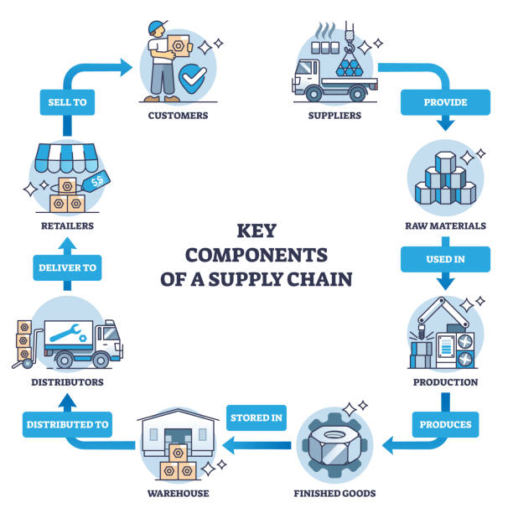

**Fig No 4.1 Operations in Delman Logistics**

**A. Objectives of Operations Department:**

1. To Ensure Smooth Day to Day Operations by optimizing routes and ensuring the system functions without friction.
2. To Improve Efficiency and Reduce Costs by cutting unnecessary spending and finding smarter ways to work, essential for profitability.
3. To Coordinate Between Teams and Partners by maintaining seamless communication and collaboration across internal and external networks.
4. To Solve Problems Quickly by providing rapid and effective troubleshooting when delays or challenges arise, minimizing disruption.
5. To Maintain High Safety and Compliance Standards by adhering to strict protocols and regulations to protect people, cargo, and legal standing.
6. To Support Customer Satisfaction by delivering on promises, providing transparency, and offering reliable service to build long-term client relationships.
7. To Continuously Improve Processes by adapting to new technologies and market demands to maintain a competitive edge.
   * 1. **Duties and Responsibilities of Operations Department**

The operational role is fundamentally about execution and oversight, beginning with the daily task to monitor and manage daily shipping activities. This involves closely watching all outgoing and incoming cargo movements to keep the supply chain flowing. A critical part of this is logistics scheduling, specifically the need to coordinate vessel arrivals and departures, ensuring ships arrive and leave on time to maintain port efficiency and delivery schedules. This coordination requires constant communication, so the job demands strong skills to communicate with shipping agents, port authorities, and clients alike, ensuring everyone is on the same page regarding movement details.

Beyond communication, the role involves significant administrative work. Team members must handle cargo documentation and tracking, managing Bill of Lading, manifests, and other paperwork while providing real-time updates to stakeholders. A core efficiency goal is to ensure timely loading and unloading of goods, minimizing idle time at ports to save costs and accelerate delivery. When inevitable hiccups occur, whether they are equipment breakdowns or unexpected customs hold-ups, the person must be ready to solve operational issues and delays quickly and effectively.

Accountability is maintained through meticulous record-keeping; it's essential to maintain accurate records and reports for both internal auditing and client transparency. This ties directly into the critical responsibility to ensure compliance with safety and legal regulations, which protects the company from penalties and ensures secure handling of all cargo. Furthermore, the role provides direct support, helping to support logistics and transport planning by providing ground-level data and operational feasibility. Finally, success in logistics is a team effort, requiring the ability to collaborate with other departments to meet customer needs, whether working with sales on a new contract or finance on payment terms.

* + 1. **Key Resources of Operations Department**

At the heart of any successful logistics company is the human element, led by a Skilled operations team. These are the experts who drive the daily execution. Their work is supported by essential physical assets, primarily a Fleet of vessels and chartered ships, which provides the core capacity to move goods across the sea. To manage this complex network efficiently, the company relies on Advanced logistics and tracking systems for planning, visibility, and control over every shipment from origin to destination.

Beyond the internal resources, strong external relationships are crucial. Key among these are Port and customs relationships, which allow for smoother processing and faster clearances, minimizing delays. Complementing this is a Strong vendor and supplier network, ensuring reliable access to everything from fuel and maintenance to specialized services when needed. To maintain consistency and quality across all operations, the company utilizes well-defined Standard operating procedures (SOPs), which guide every task and decision.

Operational efficiency relies heavily on connectivity, powered by excellent Communication and coordination tools that link the office team with vessels, port agents, and clients in real time. Safety is non-negotiable, so robust Safety and compliance systems are in place to protect personnel and cargo while meeting all regulatory requirements. The physical movement of goods is handled using Real-time cargo handling equipment that integrates directly with the tracking systems for greater accuracy. Finally, management relies on Data and performance analytics tools to continuously assess operational health, identify bottlenecks, and inform strategic decisions for future improvement.

**D. Programmes, Policies and Procedures of Operations Department**

The foundation of maritime operations relies on meticulous planning, starting with a comprehensive Vessel scheduling and route planning programme. This system optimizes travel paths to ensure efficiency and timely delivery. Complementing the planning is the Cargo handling and stowage policy, which dictates how goods are loaded, secured, and managed on board to maximize safety and space utilization. Underlying these operational protocols are strict guidelines for Safety and environmental compliance procedures, ensuring that the company protects its crew, cargo, and the marine environment in adherence to all regulations.

Smooth functioning at every stop is governed by the Port operations coordination programme, which dictates the seamless interaction with port authorities for efficient loading, unloading, and departure. Because the sea can be unpredictable, a rigorous Emergency response and incident management plan is essential to handle any crisis, from mechanical failure to severe weather. The well-being and management of personnel are guided by the Crew management and welfare policy, ensuring that all staff are properly trained, supported, and cared for.

Operational readiness is maintained through systematic routines, including strict Maintenance and inspection schedules for all vessels and equipment to prevent costly breakdowns. The quality of external services is managed through Vendor and service provider evaluation procedures, ensuring the company partners only with reliable suppliers. Administrative rigor is secured by a robust Document control and regulatory compliance policy, which keeps all necessary paperwork accurate and up-to-date for inspections and legal adherence. Finally, the company ensures its long-term viability and expertise through a commitment to a Continuous improvement and training programme, constantly updating skills and refining processes based on performance data and industry best practices.

**4.2 Customer Service Department**

The Customer Service team at Delman Shipping LLC knows that importing goods whether by sea or air can be complex and overwhelming, especially with tight deadlines or unexpected delays. That’s why they focus on being not just helpful, but genuinely supportive throughout the entire process. From the first inquiry to final delivery, the team guides customers step by step explaining procedures, clarifying costs, and ensuring all paperwork is in order. They keep a close watch on each shipment and provide timely updates, so clients always know what’s happening and what to expect next.

What truly sets this department apart is their personal approach. They don’t treat customers like just another file or tracking number. Instead, they take the time to understand each business’s unique needs and priorities. Whether it’s helping a small importer bring in their first shipment or supporting a large company with weekly cargo, the team is patient, responsive, and solution-oriented. At Delman, customer service isn’t just about answering calls it’s about building real relationships and making logistics feel a little less stressful and a lot more human.

* + 1. **Objectives of Customer Service Department**

1. To Ensure timely and accurate communication with clients regarding all aspects of their shipments.
2. To Provide end-to-end support for both sea and air import shipments from initiation to final delivery.
3. To Build strong, trust-based relationships with customers through consistent reliability and engagement.
4. To Deliver quick and effective solutions to all shipment issues, minimizing client disruption.
5. To Maintain high levels of customer satisfaction and loyalty through excellent service quality.
6. To Coordinate smoothly with internal teams and external partners to ensure seamless service delivery.
7. To Keep customers informed with real-time shipment updates for complete transparency.
8. To Educate clients on shipping processes and documentation to simplify their involvement and ensure compliance.
   * 1. **Duties and Responsibilities of Customer Service Department**

The customer service role begins with direct engagement, requiring the team to respond to customer inquiries related to imports promptly and accurately. From there, the team takes charge of the logistical coordination, having to coordinate shipment bookings and follow-ups with carriers to secure necessary space and timelines. Throughout the shipping journey, a key responsibility is to monitor and update customers on shipment status and delays, maintaining transparency at all times.

Beyond simple updates, the team plays a crucial supportive role, needing to assist with documentation, customs, and clearance processes to ensure legal compliance and avoid hold-ups. When issues inevitably arise, staff must be equipped to resolve issues and escalate problems when needed, acting as the main point of contact for troubleshooting. This support network extends globally, demanding the ability to maintain clear communication with overseas agents and partners to ensure a seamless cross-border service.

Ultimately, the goal is long-term business success, achieved by working to build positive, long-term relationships with clients based on trust and consistent service. This relationship is strengthened by efforts to track and manage customer feedback for service improvement, using client input to refine internal processes. Success requires internal harmony, necessitating the need to collaborate with operations, sales, and logistics teams to deliver a unified service. In all actions, the primary mandate is to ensure all services meet company standards and customer expectations, upholding the brand's commitment to quality.

* + 1. **Key Resources of Customer Service Department**

The heart of excellent client interaction is the human capital: an Experienced and customer focused service team that possesses the empathy and knowledge to manage complex import inquiries. This team is empowered by necessary technology, primarily Shipment tracking and communication software that provides the visibility required to keep clients informed and manage expectations. Complementing their skills is the essential intellectual capital: Up to date knowledge of import regulations and procedures to guide clients through customs and compliance requirements without error.

External partnerships are vital to service delivery, built upon Strong relationships with airlines, shipping lines, and agents to ensure priority handling and swift resolution of issues. Internally, the service team must have immediate Access to internal logistics and operations data to provide accurate, real time status updates. Managing the administrative load is simplified by effective Document management systems for customs and compliance, which organize the large volume of paperwork inherent in international shipping.

Service quality is standardized and reinforced through Well developed customer service protocols and response workflows, ensuring a consistent and efficient experience for every client. Communication speed is paramount, supported by reliable Real time communication tools such as email, phone, and messaging apps. To ensure the team remains at the top of its game, the company invests in Training programmes for team development and industry updates. Finally, a continuous cycle of improvement is maintained through Feedback and CRM systems to understand and improve client experience, using data to refine service quality and build lasting loyalty.

**D. Programmes, Policies and Procedures of Customer Service Department**

The service lifecycle starts with the Client onboarding and orientation programme, which ensures that new customers are seamlessly integrated and understand how to engage with the company’s services. This is immediately supported by a Standard operating procedure (SOP) for handling inquiries and complaints, ensuring every question and concern is addressed consistently and efficiently. Keeping clients in the loop is central to trust, managed by a clear Shipment tracking and update policy that mandates how and when clients receive status notifications.

Quality control is maintained through a structured Service quality assurance and feedback programme, which proactively seeks client input to measure performance and identify areas for improvement. When routine problem-solving isn't enough, a defined Escalation procedure for urgent or unresolved issues ensures that complex matters are quickly brought to the attention of senior management for resolution. The manner in which the team communicates is critical, governed by a Communication policy for timely and clear client updates that prioritizes clarity and professionalism.

Administrative diligence is upheld through a robust Documentation and compliance checklist procedure, ensuring all necessary paperwork is processed correctly to avoid customs delays. Beyond single transactions, the company focuses on long-term value through a comprehensive Customer follow-up and relationship management programme. Success depends on internal harmony, achieved via an Internal coordination workflow with operations and logistics teams that ensures seamless service delivery. Finally, the team's continuous excellence is guaranteed by a Training and development policy for service team members, which keeps their knowledge current and skills sharp.

**4.3 Sales and Client Relations Department**

At Delman Shipping LLC, the Sales & Client Relations Department for sea and air imports plays a key role in building lasting partnerships and driving business growth. This team is often the first point of contact for potential clients, listening carefully to their logistics needs and offering tailored shipping solutions that work across both air and sea channels. They don't just focus on closing deals they focus on building trust. Whether it's a small business importing for the first time or a large enterprise looking for reliable logistics support, the team works hard to understand each client's goals and recommend services that make sense both operationally and financially.

Once a client comes on board, the relationship doesn't stop there. The team continues to check in, follow up, and ensure the client is satisfied with the service, acting as a steady point of contact and advocate within the company. They also keep a close eye on market trends, shipping rates, and capacity so they can offer clients timely insights and competitive options. What makes this department stand out is their human approach they’re approachable, responsive, and genuinely invested in helping clients succeed, shipment after shipment.

**A. Objectives of Sales and Client Relations Department**

1. To Build and maintain strong relationships with both new and existing clients for long-term partnership.
2. To Understand client needs and offer tailored sea and air import solutions that meet their specific requirements.
3. To Increase sales through strategic outreach and market development initiatives.
4. To Provide accurate and timely quotations for all requested import services.
5. To Collaborate with operations to ensure smooth service delivery and problem resolution.
6. To Act as the client’s voice within the company to champion their needs and ensure satisfaction.
7. To Follow up on leads and convert inquiries into long-term partnerships.
8. To Keep clients informed about shipping options, rates, and relevant industry changes.
9. To Identify opportunities for upselling or cross-selling services to maximize value for both the client and the company.
10. To Ensure a positive, professional, and helpful customer experience from the very first point of contact onward.
    * 1. **Duties and Responsibilities of Sales and Client Relations Department**

The sales function is centered on proactive client engagement, which begins by reaching out to potential clients and presenting import service offerings. The next essential step is to understand each client’s specific shipping needs and suggest suitable, customized solutions. Once a solution is identified, the sales team must swiftly prepare and send competitive quotes for both sea and air import shipments, ensuring accuracy and timeliness.

Client relationships are maintained throughout the process by keeping regular communication with clients during the shipment journey. This necessitates close collaboration, so the sales representative must coordinate with operations and customer service to ensure that client expectations for delivery and service are consistently met. The role also involves relationship management, requiring the sales professional to handle client inquiries, feedback, and concerns with utmost professionalism and care, turning potential issues into opportunities for trust-building.

To drive business growth, the team needs to track sales performance and consistently follow up on leads and proposals to convert interest into finalized partnerships. The ultimate goal is to build long term relationships through consistent support and sustained engagement, making the client feel valued well beyond the first transaction. This requires continuous professional development; sales staff must stay updated on shipping trends, carrier rates, and industry changes to provide informed advice. In every interaction, the representative must embody the company's values, choosing to represent the company with integrity and a client first mindset.

* + 1. **Key Resources of Sales and Client Relations Department**

The sales function relies fundamentally on its human resources, specifically a Knowledgeable and personable sales and client relations team capable of building rapport and offering expert advice. This team is technically supported by robust tools, particularly CRM (Customer Relationship Management) software used to meticulously track leads, manage client history, and log all interactions. They rely on essential data, maintaining an Updated database of shipping rates, carriers, and service options to quickly generate accurate and competitive quotes.

Crucial external resources include Strong relationships with freight partners, airlines, and shipping lines, which are necessary to secure competitive pricing and reliable service capacity. Internally, the sales team ensures alignment by having Access to internal operations and customer service insights, allowing them to promise service delivery that the company can reliably execute. Their outreach efforts are supported by professionally designed Marketing materials and sales tools that articulate service value to potential clients.

Effective communication is the lifeblood of sales, maintained through Reliable communication channels including phone, email, and various messaging platforms. Strategic selling is informed by continuous analysis, with the team utilizing Market research and trade lane intelligence reports to identify new opportunities and understand competitor moves. Service quality is continuously refined through Client feedback systems, which are used to improve engagement strategies and overall client experience. Finally, the team’s expertise is maintained through Ongoing training programmes designed to keep them current with industry trends and evolving client needs.

* + 1. **Programmes, Policies and Procedures of Sales and Client Relations Department**

The structure of the sales and client relations department is built on a few core processes designed for growth and retention. The journey begins with the Client onboarding and relationship building programme, which focuses on welcoming new customers and immediately establishing a foundation of trust. This is sustained by a robust Lead generation and follow up procedure that ensures potential business opportunities are consistently pursued and converted into active accounts. When it’s time to price a job, the team adheres to a strict Sales quotation and proposal preparation policy to ensure that all pricing is accurate, competitive, and timely.

Maintaining client loyalty is managed through a comprehensive Customer feedback and satisfaction tracking programme, which provides quantifiable data to assess performance and identify areas needing attention. To ensure a professional client experience, the team follows a defined Client communication and response time policy, setting clear expectations for how quickly inquiries will be addressed. Internally, accountability is driven by a formal Sales performance monitoring and reporting procedure used to track progress against targets and inform strategic decisions.

Navigating challenges is essential, so a clear Conflict resolution and escalation handling policy is in place to manage disagreements or serious service issues quickly and fairly. Successful service delivery relies on seamless teamwork, achieved through a structured Coordination workflow with operations and customer service teams, ensuring the promises made by sales can be fulfilled by the rest of the company. Long term viability is guaranteed by the Account management and retention strategy, which focuses on nurturing existing business and maximizing client lifetime value. Finally, the team's ongoing excellence is secured by a comprehensive Training and development programme for sales and client relations staff, keeping their skills current with market demands and industry changes.

**4.4 Finance Department**

The finance department plays an important role in managing the financial aspects of the company’s import operations. This team is responsible for ensuring that all financial transactions related to sea and air imports are handled efficiently and accurately. From processing payments to suppliers and collecting payments from customers, to managing accounts payable and receivable, the finance team is the backbone of the company’s financial operations. They work closely with other departments to ensure that financial considerations are taken into account in every aspect of the import business.

The finance team in logistics is also responsible for providing financial insights and guidance to support business decisions. They analyse financial data to identify trends, opportunities, and risks, and provide recommendations to improve profitability and efficiency. With their expertise and knowledge of the logistics industry, the finance team helps the company navigate the complexities of international trade and logistics, ensuring that delman shipping logistics remains competitive and successful in the market. By working closely with other teams, the financial department plays a critical role in driving business growth and ensuring the company’s long-term success.

* + 1. **Objectives of Finance Department**

1. To Ensure accurate and timely financial reporting for all internal and external stakeholders.
2. To Maintain effective cash flow management to guarantee liquidity and meet short-term obligations.
3. To Monitor and manage company expenses and budgets to control costs and ensure financial discipline.
4. To Support strategic financial planning and decision-making by providing timely analysis and forecasts.
5. To Ensure compliance with financial regulations and tax laws to maintain legal standing and avoid penalties.
6. To Provide financial insights to improve business operations and enhance overall performance.
7. To Safeguard company assets and reduce financial risks through robust internal controls and risk management.
8. To Maintain transparent financial records for audits, regulatory reviews, and stakeholder confidence.
9. To Optimize profitability through cost management and revenue growth strategies.
10. To Collaborate with other departments to align financial goals with operational needs and drive business success.
    * 1. **Duties and Responsibilities of Finance Department**

The core function of the finance team is meticulous record-keeping and reporting, beginning with the mandate to Prepare and maintain accurate financial statements and reports for both internal and external scrutiny. This is built upon the foundational, daily work to Manage day to day accounting and bookkeeping tasks, ensuring all transactions are recorded correctly. A key responsibility for business health is to Monitor company cash flow, receivables, and payables, actively managing the money coming in and going out to ensure liquidity. Furthermore, the team must strategically Create and oversee budgets for various departments, controlling expenditures to align with the company's financial goals.

Beyond basic accounting, the department handles personnel finance by needing to Handle payroll processing and employee reimbursements accurately and on time. A critical, external-facing role is to Ensure compliance with tax laws, VAT, and financial regulations to maintain the company’s legal and fiscal standing. This compliance is verified by the need to Conduct internal audits and support external audit processes, providing transparency and assurance. The finance team isn't just about reporting; they must actively Analyse financial data to support management decisions, offering insights that drive strategic choices across the organization.

The relationship with financial institutions is managed by the function to Oversee banking relationships and manage company accounts, ensuring efficient banking operations. Finally, they serve as the financial voice of the company, with the duty to Provide regular financial updates to leadership and stakeholders, communicating the company's fiscal health and performance clearly and consistently.

* + 1. **Key Resources of Finance Department**

The financial health of the organization is powered by its human resources, specifically Experienced finance and accounting professionals who bring expertise and accuracy to every task. This team relies heavily on technology, utilizing Accounting and financial management software as the backbone for all bookkeeping, transaction recording, and reporting. To ensure all operations are legal and compliant, the team maintains Up to date knowledge of financial laws and regulations, staying ahead of changes in tax and fiscal requirements.

Financial security is paramount, secured by Robust internal controls and audit systems that safeguard company assets and prevent fraud or error. External relationships are also key, particularly Strong relationships with banks and financial institutions, which ensure favorable terms and efficient management of company funds. Management decisions are supported by data, relying on Real time financial data and reporting tools that provide immediate, actionable insights into the company's fiscal status.

The finance department cannot operate in isolation; it maintains Collaborative ties with other departments, ensuring financial goals are aligned with operational realities. Meticulous organization is essential, facilitated by efficient Document management and filing systems for all invoices, contracts, and financial records. Finally, to ensure the team’s ongoing competence and professional standards, the company invests in Regular training and development programmes to keep staff skilled and informed about industry best practices.

* + 1. **Programmes, Policies and Procedures of Finance Department**

The foundation of financial stability rests on clear transaction management, starting with strict Accounts Payable and Receivable Procedures that define how the company collects payments and settles its own debts. This daily flow is governed by a meticulous Cash Flow Monitoring Policy to ensure sufficient liquidity at all times. All transactions are rigorously managed according to the Financial Reporting Standards and Procedures, which dictate how statements are prepared for both internal review and external stakeholders.

Fiscal health is secured through strong risk management and compliance. A robust Internal Control and Risk Management Policy is in place to safeguard company assets and prevent fraud or error. This is complemented by the Regulatory and Tax Compliance Policy, which ensures strict adherence to all local and international tax laws, including VAT. To verify all processes are sound, the Audit Preparation and Support Programme mandates systematic readiness for all internal and external reviews. Meticulous Document Retention and Filing Procedures ensure that all financial records are properly archived for compliance and future reference.

Specific financial workflows are also formalized. Employee finance is managed through the Payroll Processing and Salary Disbursement Procedure, guaranteeing accurate and timely compensation. A separate Expense Management and Reimbursement Policy governs how employee spending is controlled and repaid. Furthermore, the Vendor Payment Scheduling and Verification Procedure ensures that external partners are paid correctly and on time, maintaining strong business relationships. Looking to the future, the company uses a Financial Forecasting and Budgeting Programme to plan resource allocation strategically. Finally, the department ensures its own competence through a Staff Training and Financial Systems Development Programme, keeping its professionals updated on best practices and new technology.

**Fig.No.4.2 Learning Summary from Each Department**

| **Department** | **Key Learnings** | **Practical Exposure** |
| --- | --- | --- |
| Operations | Import cycle understanding | Tracking and customs |
| Customer Service | Client communication | Issue resolution |
| Sales & Client Relations | Marketing logistics services | Client meetings |
| Finance | Documentation and billing | Payment follow-ups |

**CHAPTER 5**

**CONCLUSION**

**5.1 Critical Appraisal of Delman Shipping LLC**

The intern's time at Delman Shipping LLC proved to be a profoundly valuable learning experience. From the very start, the welcoming and friendly environment made the intern feel comfortable and immediately integrated as part of the team. This supportive culture was key to facilitating a smooth introduction to the practicalities of the shipping and logistics business, which included essential tasks like handling complex documentation and tracking shipments.

The staff at Delman demonstrated exceptional patience and mentorship, consistently offering clear explanations and sharing their professional experiences. A particularly appreciated aspect of the environment was the respect shown to the intern, despite their nascent position. This approach fostered both personal and professional growth throughout the duration of the placement.

The two-month internship provided the student, an MBA candidate specializing in Finance and Marketing, with a deep and multifaceted understanding of the logistics and shipping industry, focusing specifically on the Sea and Air Imports departments. The student was keen to apply their theoretical knowledge in a real-world setting. They were immediately impressed by the company's well-structured operations, particularly how successfully it managed to balance the intricacies of international logistics with the inherent financial complexities. The intern noted that the fast-paced nature of the work was offset by the seamless and exciting collaboration between the operations and finance teams.

The company culture at Delman Shipping was a significant highlight. Despite the high-pressure demands of the logistics sector, the atmosphere remained supportive and collaborative. Team members, irrespective of their specific roles, consistently allocated time to explain processes, answer questions thoroughly, and provide constructive feedback. Ultimately, the internship at Delman Shipping was an invaluable experience that not only enhanced the intern's technical skills but also underscored the critical importance of teamwork and customer-focused service. The intern left feeling grateful for the opportunity to learn from such a dedicated team and for the lasting professional relationships established, recognizing the experience as a crucial step that has shaped their career perspective.

**5.2 Learning Experience at Delman Shipping**

My two-month internship at Delman Shipping as an MBA student was a truly eye-opening learning experience that went far beyond what I had expected. Being part of the Sea and Air Imports department allowed me to witness the real-world application of both finance and marketing principles I had studied in class. From understanding tracking of shipments and managing import documentation to analyzing costs and understanding client communication strategies, every day presented a new learning. I was able to see how operations and finance work hand-in-hand to keep the supply chain running smoothly, even amidst tight deadlines and unforeseen challenges. What made the experience truly meaningful was the people, I was surrounded by professionals who were not only skilled but also kind and approachable. They took time to explain things, encouraged me to ask questions, and treated me as a valuable part of learning from them, as an intern. I learned to think on my feet, pay attention to details, and communicate more clearly, all of which have helped me grow both personally and professionally. This internship didn’t just give me knowledge, it gave me confidence, direction, and a real sense of what it means to work in a dynamic, people-centered industry.

**5.3 Conclusion**

The conclusion of the intern's two-month placement at Delman Shipping was marked by a strong sense of gratitude for the learning, growth, and dedicated support experienced. The internship was regarded as far more than a simple academic requirement; it was a defining professional chapter that equipped the intern with valuable knowledge about the logistics industry, fostered important professional relationships, and provided real-world exposure to the dynamics of the shipping business. The guidance and constant support from the team were highlighted as crucial to the learning process, ultimately strengthening the intern's understanding of operations and boosting their personal confidence for future career steps.

* 1. **Suggestions**

The intern concluded their two-month placement at Delman Shipping with deep gratitude for the growth and support provided. The experience surpassed a mere academic requirement, becoming a crucial professional chapter where the intern gained valuable logistics knowledge, built key relationships, and absorbed the real-world dynamics of the shipping industry. The team's guidance was essential to the learning process, ultimately strengthening the intern's operational understanding and significantly boosting their career confidence.

**BIBLIOGRAPHY**

**Bibliography**

**Books**

1. Supply Chain Management: A Logistics Perspective (11th Edition) (2021), C. John Langley Jr., Robert A. Novack, Brian J. Gibson, John J. Coyle, published by Cengage India.
2. Lean Supply Chain and Logistics Management (2023), Paul Myerson, published by McGraw-Hill Education.
3. Logistics Management (2020), Tan Miller, Matthew J. Liberatore, published by Business Expert Press.

**Websites**

1. [www.delmanshipping.com](http://www.delmanshipping.com)
2. [www.logisticsmgmt.com](http://www.logisticsmgmt.com)
3. [www.supplychain247.com](http://www.supplychain247.com)
4. [www.zaubacorp.com](http://www.zaubacorp.com)
5. [www.allcargologistics](http://www.allcargologistics)
6. [www.freightera.com](http://www.freightera.com)